February 9, 2022

Dear YMCA Child Care Families,
Unfortunately, we were advised that a staff member at our Pope Francis Early Learning Child Care Centre tested positive for COVID-19 on a rapid antigen test. The staff member was last at the centre on February 9, 2022.
A deep cleaning and disinfecting of the child care rooms is underway.
I want to reassure you that we will continue to keep you informed of any new updates. In keeping with our core values, being transparent is paramount, that is why we are informing all YMCA staff and families, and this communication will be posted on our website.
Should you have further questions, please do not hesitate to contact me.
Thank you for your continued support, stay well.
Sincerely,
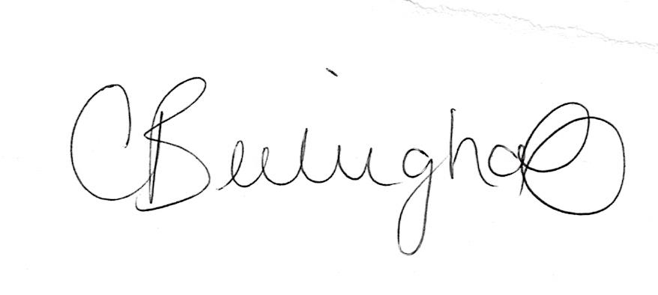
Courtney Berlinghoff
Regional Manager, Timmins

