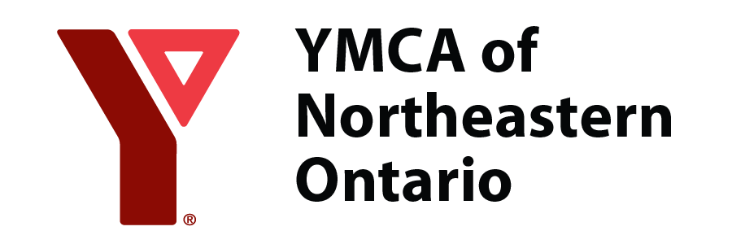
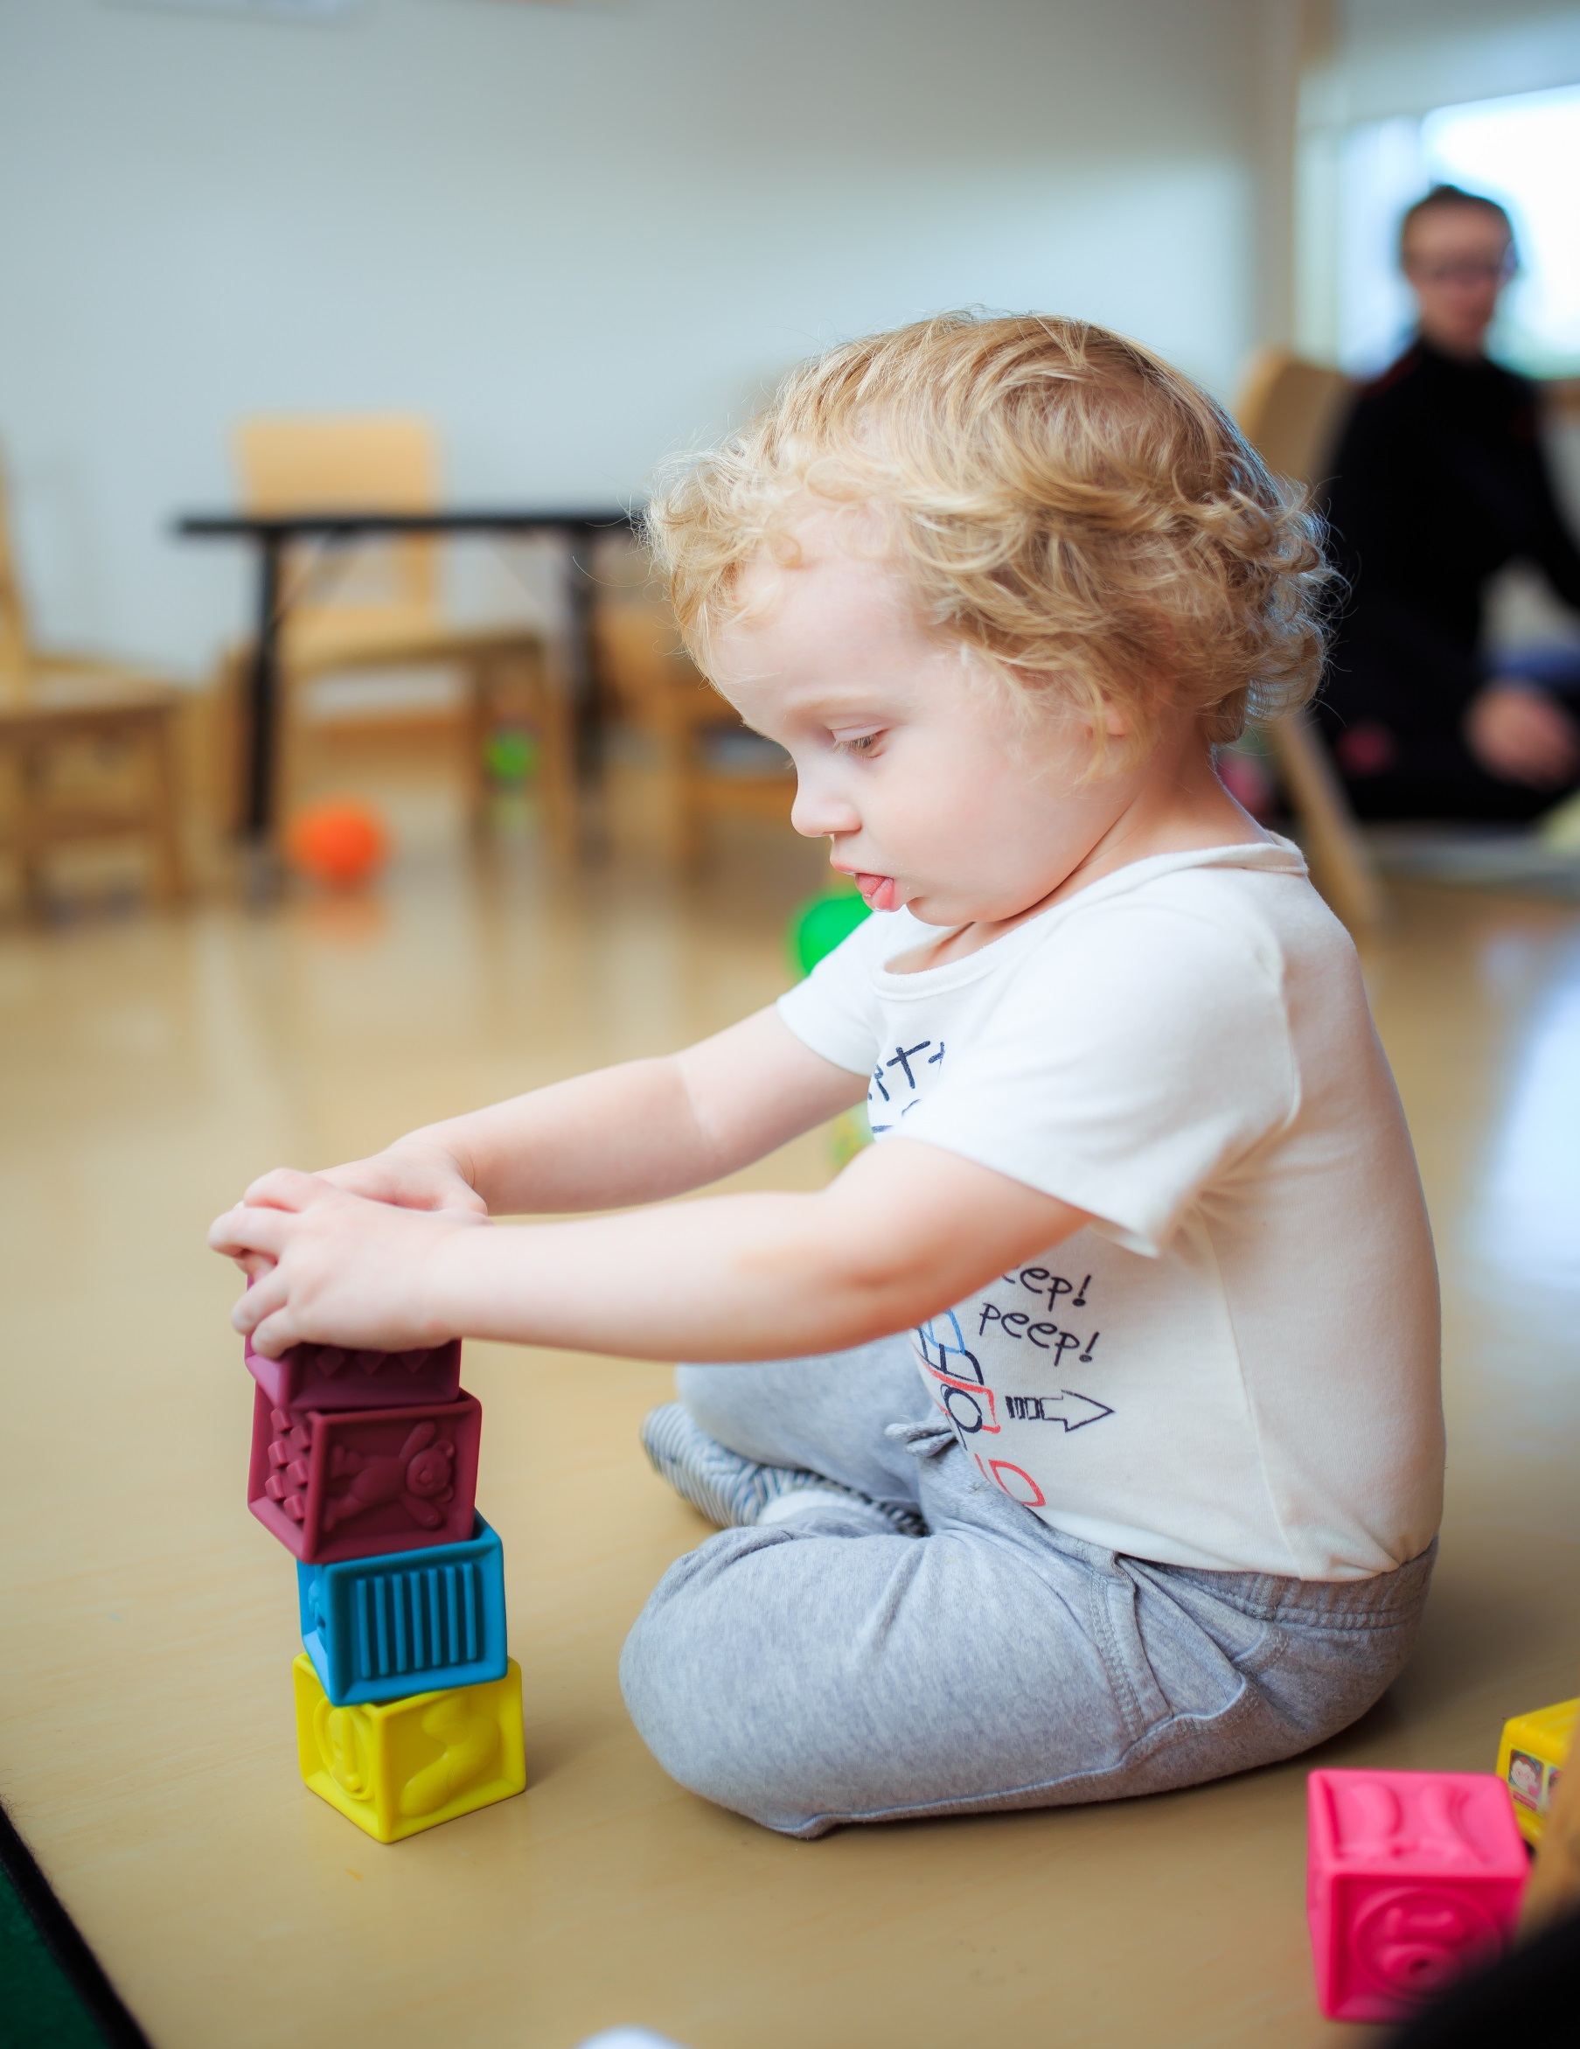
Child Care and Early Learning Centres
Family Information Guide
October 2022

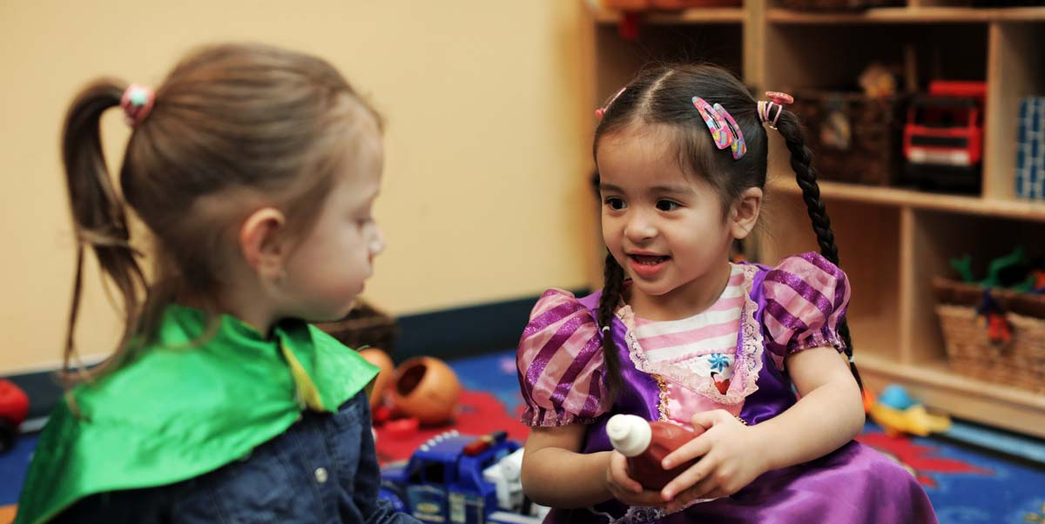

Welcome to the YMCA of Northeastern Ontario!
Table of Contents

Getting Started Checklist 3

Program Statement Introduction 4

YMCA Curriculum 6

Program Information 10

Canada Wide Early Learning and
Child Care Program Information 12

Anaphylaxis Protocol, Nutrition, and
Bagged Lunch Policies 22

Weemarkable App 25

Addressing Parental Concerns 28

Curriculum Goals and Approaches 30

Charitable Purpose, Vision,
Core Values and Other Services 42

The YMCA puts the interest of your child as its top priority and values parents as the experts of their children. We look forward to embarking on a partnership with you to ensure your child reaches their full potential.
We hope that you find the enclosed information helpful in your child care journey with the YMCA. At the YMCA, we have an open door policy and your feedback is always welcome and appreciated.

If you have any questions, please do not hesitate to contact any member of our Early Learning Child Care Team.
Thank you for choosing the YMCA of Northeastern Ontario Licensed Child Care Services.

Respectfully,
Jacqueline Grube, RECE,
Vice President, YMCA Child, Youth & Family Development
As We Grow
Good Start Checklist
As we continue to navigate and finalize our recent amalgamation with the YMCA of Timmins, families may experience some regional differences. If you have any questions or concerns with these differences, please contact the supervisor at your child’s centre.

We Want to Hear From You!
- Spend time with your child’s educator in the morning when you arrive to share any pertinent information that will help us care for your child.
- Notify the Main/Centre office if your child has any food or other allergies.
- Let us know about your child’s toilet training needs.
- If your child is sick or will be absent, please call the Main/Centre office by 9:00am.
- If you move, change jobs or change any of your telephone numbers, please let the Main/Centre office know.
- Notify the Main/Centre office if someone different will be dropping and/or picking up your child.
- Have a back-up plan for child care when your child is ill and cannot come to the Centre.
- Please remember that your child is busy learning through play and will get messy. When dressing your child for care in the morning, please remember this when choosing clothing.

A Good Start – What Should My Child Bring?
- Label all of your child’s clothing and personal items, including diaper cream.
- Keep two extra sets of clothing at the Centre for your child.
- Indoor running shoes and socks are required. (flip-flops and crocs are not considered safe for play)
- Bring outerwear each day for your child (remember to label everything).
- Bring sunscreen (labeled with your child’s name).
- Sheets and blankets will be provided for the cribs and cots in your child’s room. We will wash them every Friday after rest time for the following week.
- (Timmins programs only) Provide a blanket and pillow (optional) for nap time. Blanket is to be taken home on Friday to be washed and returned on Monday morning.
- Comfort items such as blankets, stuffed toys are welcome. The YMCA is not responsible for lost or stolen items.
- Provide a weekly supply of disposable diapers (if needed) or cloth diapers (will only be used if a disposable liner is provided and soiled diapers are to be brought home on a daily basis)
- Outside food is not permitted to ensure a safe environment for all our children. If your child has food restrictions, please notify the Child Care Supervisor so arrangements can be made.
- School-Aged Program attendees are required to bring a lunch following our Bagged Lunch requirements. (page 23) on all non-instructional days.

Program Statement Introduction
Program Statement Introduction
Welcome to YMCA Licensed Child Care. Our program statement describes how our programs support and foster early learning. It will outline our view of the child, our philosophy and pedagogy as well as the goals and approaches used to ensure healthy child development. It will also outline how we evaluate our programs to maintain quality and how we support the professionals who work with the children. The YMCA Child Care Program Statement is reviewed annually to ensure it is aligned with the Minister of Education’s Policy Statement.

Our View of the Child
Every child is special in the eyes of their parents and those who love them. The children are also special to us. As Educators of young children, we know that each child is an individual of great human worth and potential. Every child is different: in their looks, their growth patterns, their genetic make-up, their previous experiences, the way they think, and in every aspect of what makes them human beings. We appreciate, value, and celebrate each child’s uniqueness, and we view the child’s growth and development as occurring in a holistic manner.

At the YMCA, we understand that children learn through play. Play by definition is enjoyable, spontaneous, active, and undertaken without external goals and sanctions. This means children are self‐learners and do not require an adult to choose what or how they should learn. When the child’s natural activity of play is supported by caring and responsive professionals in positive, developmentally appropriate learning environments, we believe, a child will flourish. The child’s innate competence, capacity, curiosity and potential will be maximized.

“[YMCA Playing to Learn] is a wonderful, academically sound, and highly accessible document. At the heart is a view of children, teachers and parents as capable and competent. This is one document that will be highly valued in the field, not just sitting on a shelf.”
Jean M. Clinton, BMus MD FRCP(C), Associate Clinical Professor, Department of Psychiatry and Behavioural Neurosciences, McMaster University

Philosophy
The study of the theoretical basis of a particular branch of knowledge.
Pedagogy
The method and practice of teaching.
Approach
A means of attaining a goal, aim, and/or desired result.
.
Holistic Development
The philosophy or view of human development that recognizes the necessity to include all aspects or domains of development in order to understand the whole person.
Sanction
For a recognized authority to give approval of something.

Innate
Existing from birth (i.e. born with).

Our Statement on Play
Program Statement Introduction
Each child can reach their full human potential through play. Our intention is to provide the best possible environment that allows the best possible play for all children in our care. We endeavour to meet the play needs of all children and must do whatever possible to support their natural urge to play.

Play helps the child to be both engaged with everyday realities and to be absorbed in an ecstatic self-forgetfulness. It ensures involvement, enjoyment and various forms of success. Play can be powerful or profound, but it is always purposeful.

Play is a vehicle that propels learning and development. Play and development are intertwined; neither precedes the other. All domains of development are supported by play, and play has the additional benefit of being self-initiated and therefore a joy rather than a chore. Play makes discovery fun, but it also propels the child into the vast realm of learning. Play provides a way for children to be healthy in body, mind and spirit.

Play fosters skill development. It offers opportunities for gaining new skills as well as refining existing ones.

Play is directly linked to the child’s learning. Cognitive development and academic success are enhanced by every play experience.

Play is physical and increases activity levels, fitness, balance, gross motor skills and fine motor actions. A wide range of scientific, mathematical, perspective-taking and other cognitive processes in discovery and other types of play.

Play is social and aids in language learning while supporting social skills development. Self-concepts and emotions are better understood through play, as is the building of emotional intelligence. Important self-regulatory skills may be acquired and reinforced through play.

Play builds resilience and can help children manage stress. There are often therapeutic benefits to play. Typically, children direct their play in ways that address their own socio-emotional issues.

Learning
The process of changing existing understanding to accommodate new ideas; acquiring new knowledge, skills, and/or dispositions; discovering through play.

Body
The physical self.

Mind
The individual’s place of thinking; human consciousness emanating from the brain.

Spirit
The part of the self that transcends the physical self or thought processes.

Developmental Domains
The categories that academics and practitioners use to manage the vast amount of information about human development.

Skill
A learned behaviour.

Cognitive
Related to thinking or reasoning.

YMCA Curriculum
The YMCA of Northeastern Ontario has been successfully implementing our national curriculum YMCA Playing to Learn in all child care programs for children 0‐6 since 2007; all YMCAs across Canada have also adopted this curriculum.
YMCA Curriculum

YMCA Playing to Learn 2nd Edition was published in 2015. This edition incorporates new research, best practices, knowledge, and experience. There is more information on infants and toddlers, and it has a greater focus on the social and emotional development of the young child.

The YMCA of Northeastern Ontario has been implementing YMCA Healthy Child Development and High-Five since 2008 and has now launched our school-age curriculum, A Place to Connect for children 5‐12 as of September 2020.

The YMCA has been involved in shaping the development of the provincial early learning framework by sharing YMCA Playing to Learn and our training materials to support educators in implementing a play-based approach. The goals and approaches of the YMCA curriculum align in philosophy, standards, and recommendations with the provincial frameworks below. It is gratifying to see the Ministry of Education embrace play and adopt a very similar approach.
Minister of Education's Policy Statement on Programming and Pedagogy www.edu.gov.on.ca/childcare/programCCEYA.pdf

"How Does Learning Happen?" Ontario's Pedagogy for the Early Years www.edu.gov.on.ca/childcare/pedagogy.html

Early Learning for Every Child Today (ELECT)
www.edu.gov.on.ca/childcare/oelf/

Curriculum
The deliberately organized part of the child’s experience and the experience that occurs through everyday aspects of life. Playing to Learn is a curriculum based on play development.
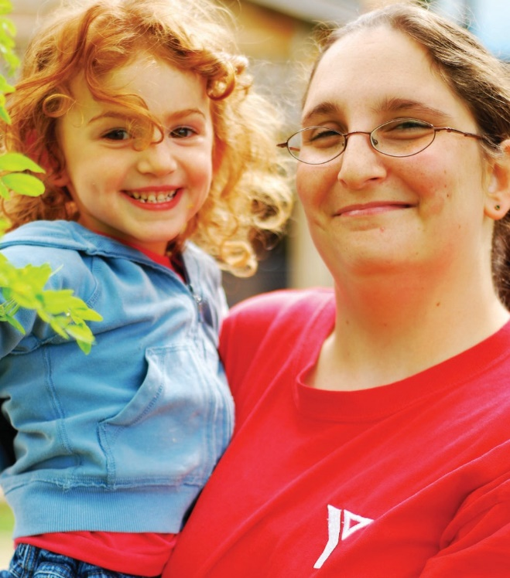
Social Learning
The process of acquiring knowledge about individuals and groups by observing, imitating, and interacting with others.

Emotional Development
The complex changes within the individual over time that involves the self and feelings and regulating behaviour.

Curriculum Connections
YMCA Curriculum
How Does Learning Happen? | YMCA Playing to Learn
Responsive Relationships | Relationships
Learning Through Exploration, Play and Inquiry | Discovery Through Play
Educators as Co-Learners | Play Partnerships, Planning Process, Reflective Practice
Environment as Third Teacher | Aesthetics, Current Interests Evident in all Learning Centres, Scaffolding & Extending
Pedagogical Documentation | Two weekly documentations are completed by each Educator and posted for families
Reflective Practice and Collaborative Inquiry | Planning Process, reflecting on over-riding interests and development of the children
YMCA Playing to Learn (Full Day)
Our YMCA Playing to Learn curriculum focuses on small group, play-based, inquiry programming provided by qualified educators who engage in play with your child. Throughout the early years your child will be learning through developmentally appropriate play experiences that will prepare them for school.
The goals and approaches of both YMCA curriculum and philosophy, standards and recommendations are from the Ontario Ministry of Education framework including:
- Minister of Education’s Policy Statement on Programming and Pedagogy;
- “How Does Learning Happen?”, Ontario’s Pedagogy for the Early Years;
- Early Learning for Every Child Today (ELECT);

For more information about the YMCA Child Care goals and approaches to supporting children and their families, please visit our website at www.ymcaneo.ca or request a copy of our YMCA Child Care Program Statement from your supervisor.

Infant (Infancy to 18 months
- Ratio is 1:3/room is 3:10
- Infants individual schedule is followed (consultation from the family is required)
- Infant daily record is documented (sleep times, eating, diapering)
- A significant play experience is written daily in each child’s Daily Play Experience
- Parent/educator conferences available upon request Educators write weekly documentations highlighting learning that occurred during a play experience to demonstrate the significance
- Includes opportunities for exploring indoors and outdoors, songs and stories, discovering creative and sensory materials, imitation play, and lots of time for hugs and cuddles
- Educators write weekly documentations highlighting learning that occurred during a play experience to demonstrate the significance
- Includes opportunities for exploring indoors and outdoors, songs and stories, discovering creative and sensory materials, imitation play, and lots of time for hugs and cuddles
YMCA Curriculum
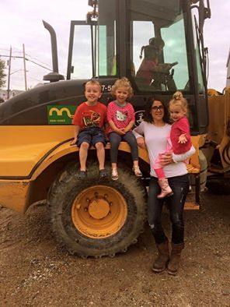
Toddler (18 months-30 months)
- Ratio is 1:5/room is 3:15
- Toddlers follow a flexible group schedule
- Daily record is documented (sleep times, eating)
- A significant play experience is written daily in each child’s Daily Play Experience
- Parent/educator conferences available upon request
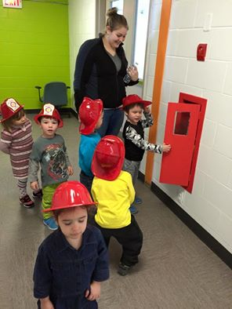
- Educators write weekly documentations highlighting learning that occurred during a play experience to illustrate how they learn through play
- Program includes opportunities for exploring indoors and outdoors, music and movement, discovering creative and sensory materials, puzzles, stories, blocks, dramatic play, learning to play with others and make choices

Preschool (30 months to 5 years)
- Ratio is 1:8/room is 3:24
- Preschool children follow a flexible group schedule
- A significant play experience is written
- daily in each child’s Daily Play Experience
- Parent/educator conferences available upon request
- Educators write weekly documentations high-lighting learning that occurred during a play experience to describe how they develop
- Program includes opportunities for
exploring indoors and outdoors, creating with the arts (visual, dramatic and music), discovering science, engaging in mathematics and literacy activities, developing social skills, gross and fine motor skills and problem-solving skills

YMCA Healthy Child (A Place to Connect)
YMCA Curriculum
(Before, After School and P.D Days)
A Place To Connect provides exemplary school-age practices meaning going to the next level with the design and implementation and programming, every aspect of the environment, each part of the curriculum, and the staff’s understanding and responsiveness to children and families. In the YMCA School-Age Program, exemplary practice will:
- Embody the Charitable Purpose, Vision and Core Values of the YMCA;
- Embrace the 40 Developmental Assets® and create a space to actualize these;
- Support parental intents for their children;
- Help to build strong kids, strong families, and strong communities.

School Age Program
(J.K. to 12 years)
- Kindergarten ratio is: 1:13
- Primary/Junior School Age ratio is: 1:15
- Junior School Age ratio is: 1:20
- Children enrolled in the school-age program have the option of attending before and/or after regular school hours and on non-instructional days (PD Days and school breaks) Program includes opportunities for physical activities indoors and outdoors, dramatic performances, works of art, nutritious snacks, interest clubs while developing leadership skills, problem
solving skills, moral understanding and intrinsic value.

Family Grouping
(Infancy to 12 years)
Since September 1, 2017, the Ministry of Education has introduced a new family grouping for licensed child care centres. This new group allows the placement of children of different ages (Infancy to 12 years) in the same group in the same play activity room.

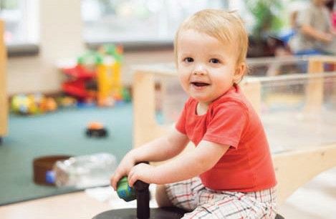
Ratios: Up to a maximum of 15 children; and no more than six children under two years of age. There are no reduced ratios permitted at any time for this age grouping.

Family age groups could also play a key role in supporting the unique and diverse child care needs of our various cultural and linguistic communities and provide opportunities for families wishing to have siblings of different ages together.

In recognizing that children develop and learn at different paces, the family age group creates opportunities to consider each individual child’s abilities and interests. How Does Learning Happen? Ontario’s Pedagogy for the Early Years helps educators to plan for and create environments and experiences that respond to the varied abilities and each child’s unique characteristics and background while maintaining safety and YMCA Core Values.
Hours of Operation
Program Information
At the YMCA, our standard hours of operation range from opening between 6:00 am-7:30 am and closing between 5:30 pm-6:30 pm, depending on the program. It is important to note that centre operations are determined by community needs. Please see your centre’s posted hours of operation, and/or feel free to speak with the child care supervisor.

Child Care Services Offered
We are pleased to offer the following Licensed Child Care and School-Age Services:
- Full Days for Infants, Toddlers and Preschool Children
- Before and After School for
School-Aged Children
- PD Days and School Breaks for
School-Aged Children
- Summer Programs (July & August Full Days) for School-Aged Children
- Family Grouping for Infants to
School-Age Children

Flexible Child Care Services
The YMCA understands the diverse needs of families when it comes to having access to high-quality, flexible child care. As we continue to assess and listen to the needs of our communities, we do our very best to accommodate them. We are pleased to offer the following:
- Part-time Care (2 or 3 days a week) (Toddlers, Preschool & School-Age).
- Flex Care Services (a minimum of 12 days are required each month).
- After-Hours Child Care (before 7:00 am or after 6:00pm)
- Drop-In Child Care Services (registration required for Toddlers and Preschoolers).
- Socialization Programs (2.5 hrs/day for Toddlers and Preschoolers).

Please feel free to speak with the child care supervisor for more details or to find out if your child's centre offers any of the above-noted Flexible Child Care Services.

Waiting List
The YMCA of Northeastern Ontario belongs to centralized child care waitlist registries for all children through your local municipality. Parents can register using the following links:
North Bay/Parry Sound: onehsn.com/Nipissing
Sudbury/Manitoulin: onehsn.com/Sudbury or dial 311
Markstay: 1 (705) 853-1486.
Timmins: 1 (705) 360-4381

Please note, there is no fee for a family to be placed on our waiting list.

Available child care spaces are to be filled by families on the waiting list according to the ordinance of sequential dates as indicated on their child care request. However, priority will be given to: families transferring from other YMCA Child Care Centres, children attending the school where we have a school-age program, and siblings of YMCA registered children.
When a space becomes available, the first person on the waiting list is contacted and asked if they are interested in the space or if they would prefer to remain on the waiting list. If they cannot be reached, contact will be attempted again the next business day. If they cannot be reached, or do not return our call within 24 hours, the next person on the list will be contacted. A family has 24 hours after initial contact has been made to confirm their acceptance of the child care space. Families on the waitlist can contact the supervisor at any time to determine their standing on the waiting list.

Tour
Program Information
Once you have been contacted by the supervisor, you and your child will be invited for a tour and orientation. This practice will help to ensure families are well informed about our program philosophy, curriculum, and that our programs are meeting your child and family’s needs. If the tour is a success, parent(s)/guardian(s) will be invited to register their child(ren).

Registration
To register, parents will receive a registration package. All forms must be returned one week prior to your child beginning child care. It is crucial that all information be completed, including payment authorization with either banking or credit card information, immunization record and emergency contacts to ensure the safety of your child. If a child’s care is being paid for by more than one payer/account, both payers must sign our pre-authorized agreement.

Returning in September
In the spring of each year, we ask that all families complete a “September Child Care Needs” form so that parents can confirm their children’s registration for September. This confirms your child’s space and is the basis for billing your child care fees for September. If your child does not need their child care space in September, you must provide two weeks written notice. If notice is not given, parents will be billed accordingly. Timely notice for withdrawal allows the YMCA to register a waiting family in child care for the start of school.
Child Care Fees
Daily fees vary based on the community in which families reside. A list of child care fees can be found on our website or parents may ask for a printed copy at any time. Should you have any questions, please feel free to speak with your supervisor at any time. We do our very best to keep fees affordable, but from time-to-time, annual cost of living and increased operational costs are considered in order for us to ensure our programs are in keeping with high-quality standards. Therefore, child care fees are subject to change and a minimum of one month's notice in writing will be provided to families.

Child care fees are paid through pre-authorized payment on the first of the month for that month. You will be given a payment schedule to view your upcoming payments by email (if provided). This amount is based on the number of days your child(ren) is registered to attend care. Any changes to your registered days must be submitted in writing and approved by the supervisor to ensure there is space.

Returned Payment
If a payment is returned for any reason, the balance owing plus the applicable service charge of $30.00 will be due. If the balance due is not paid within 7 days of being notified, child care may be suspended until payment is received in full or special arrangements are made with our Child Care Finance Department.

Late Pick-Up Policy
A late fee of five dollars for the first fifteen minutes and one dollar per minute thereafter is applied after the centre closes.

The person picking up the child will be asked to sign a late pick-up form. Applicable fees will be added to your next payment. If there is an emergency and you are going to be late, please call your centre and/or arrange for someone else to pick-up your child. Program registration may be suspended at the discretion of YMCA Management due to consistent late pick-up.

Canada Wide Early Learning and Child Care Program (CWELCC) Information SUDBURY and MANITOULIN
Canada Wide Early Learning and Child Care Program (CWELCC)

The YMCA of Northeastern Ontario has enrolled into the Canada Wide Early Learning and Child Care Program (CWELCC).

We have long advocated for a high-quality licensed child care system that is affordable and accessible. As experts in early learning and child care, we have developed and honed a research-based early learning curriculum that is now delivered across Canada. We know that high-quality early learning and child care can set a powerful trajectory for lifelong learning, resiliency and wellbeing.

Through CWELCC funding, children under the age of 6 will be eligible for a fee reduction of 25%, retroactive to April 1, 2022. Effective January 1, 2023, fees will be reduced an additional 27.75% for a 52.75% total fee reduction.

Please see the adjoining chart to see how and when fees will be affected in the Sudbury and Manitoulin Region.

Enrolled Program | Current Daily Fee  Jan. 1/22 | 25% Reduction Fee  Apr. 1/22 | 52.75% Reduction Fee  Jan. 1/23
Base Rates

Early Learning FULL DAY – 0 to 3.8 years
Infant | $58.50 | $43.88 | $27.64
Toddler | $48.00 | $36.00 | $22.68
Preschool | $44.00 | $33.00 | $20.79
Enrolled Program | Current Daily Fee  Jan. 1/22 | 25% Reduction Fee  Apr. 1/22 | 52.75% Reduction Fee  Jan. 1/23
School Age 3.8 to 5 years
Before and After School | $22.50 | $16.88 | $12.00
FLEX Before and After School | $23.50 | $17.62 | $12.00
PD Days and Breaks | $39.00 | $29.25 | $18.43
Extended Day PD & Breaks | $49.00 | $36.75 | $23.15
Admin. Fee | $10.00 | $10.00 | $10.00
Non- Base Rates

NSF Fee | $30.00 | $30.00 | $30.00
Late Pick Up Fee | $5.00/  first 15 min, $1.00/  every min. after | $5.00/  first 15 min, $1.00/  every min. after | $5.00/  first 15 min, $1.00/  every min. after

The YMCA of Northeastern Ontario has opted into and been approved for the Canada Wide Early Learning and Child Care Program (CWELCC).

Eligible families will be credited back 25% of their fees, paid retroactive to April 1, 2022. Parents will pay the 25% reduced fee amount above. At the end of the year, fees again will be reduced an additional 27.75% to a total
of 52.75% reduced fee rates.

Tax Receipts
Program Information
The YMCA will provide your child care tax receipt on or before February 28th of each year for the prior year’s fees. If you require a copy, please contact the Child Care Finance Department.

School Holidays
Care is provided on non-instructional days such as winter vacation, March Break and PD days at most locations. Please discuss arrangements with your supervisor to determine which locations offer this service, as it is based on enrollment.

Vacations & Statutory Holidays
Operating costs for child care programs are prorated, which means that our daily rate is based on the amount of days annually. Therefore there is no reduction in fees for vacation, illnesses, absences, snow days, or statutory holidays, including weather conditions or events out of our control.

YMCA Child Care Programs will be closed on the following statutory holidays; New Year’s Day, Family Day, Good Friday, Easter Monday, Victoria Day, Canada Day, Labour Day, Thanksgiving, Christmas Day and Boxing Day. If a statutory holiday falls on a weekend, our centres will be closed the following Monday. Programs may also close early on Christmas Eve and New Year’s Eve, depending on centre requirements. Fee payment is required for all statutory holidays if they fall on your regularly scheduled days.

Program Closure
Any interruption in child care services due to circumstances beyond our control will be posted on our website and/or Facebook page. In this event, staff will always attempt to contact you or your emergency contact in order for you to pick up your child. Closures are not applicable for refund of your child care fees. If our program is located in a school, we follow the guidelines of the school.

Government Financial Assistance
YMCA Licensed Child Care programs hold a purchase of service agreement with regional municipal offices. Families can apply for child care fee subsidy by contacting:
Nipissing: 1 (705) 474-1923
Parry Sound: 1 (800) 461-4464
Greater City of Sudbury: 1 (705) 671-2489 ext. 4279
Manitoulin-Sudbury: 1 (866) 397-3334
Timmins: 1 (705) 360-4381

YMCA Financial Assistance
As a charity that serves all segments of our community, the YMCA provides financial assistance in times of need. This is a short-term support made possible due to the generosity of our donors, members, volunteers, staff, corporate and community partners. For more information on how to apply, please ask your YMCA child care supervisor.

Privacy Policy
The YMCA strives to ensure that volunteers and staff conduct their relationships with each other, participants and all other Association contacts with integrity, good judgement and fairness. The YMCA respects the right of individuals as to the protection of their personal information. The YMCA is committed to maintaining the confidentiality, privacy, and accuracy of personal information it collects, uses and discloses about its participants, members, donors, parents/guardians, children, staff and volunteers.

Program Cancellations
Program Information
The YMCA will endeavour to keep programs operating which meet the needs of the community. The YMCA reserves the right to limit program components, and/or locations based on enrollment. Notice will be provided to families should we have to close a program or component.

Withdrawal of Service
The YMCA is an inclusive organization that strives to meet the needs of children and families. In situations where the program is having difficulty meeting the child’s need, it may be deemed, in the interest of the family and/or YMCA, to end care.

Child care services may be cancelled at any time upon receipt of proper written notice (10 business days). Failure to provide proper written notification will result in your payment being processed as agreed. No refund will be provided as your space has been held. Please note we are unable to accept change requests or withdrawals by phone.

Admission and withdrawal of children is at the discretion of the YMCA. In each situation where it may be necessary to withdraw services, the YMCA of Northeastern Ontario considers the following:
- Reasonable care has been given in assessing the child’s needs, including the program’s ability to support those needs;
- Special resources and other outside agency supports have been exhausted or are unavailable and we are unable to best meet the needs of the child; and
- Two-weeks written notice of withdrawal will be given to parents.

In extreme circumstances, suspension or termination of care may be immediate due to health or safety purposes without 2 weeks notice. The following additional situations may be considered cause for suspending or terminating care:
- Non-payment of program fees.
- Chronic late pick-up.
- Situations that require specialized services that the YMCA is unable to provide.
- Parents or children who exhibit unsafe or unacceptable behaviour towards children and families, staff, students or volunteers.
- Refusal by parent/guardian to meet with the YMCA staff and/or consent to the use of support services for children if deemed necessary.
Licensing and Quality Assurance
The delivery of safe and reliable programs and services is important to the YMCA. That’s why we take great pride in our own program integrity support and the good work of our community partners and the Ministry of Education in the following initiatives:
Program Information
Ministry of Education
All of our locations are licensed through the Ministry of Education. Licensing requires a yearly renewal with the Ministry which includes an inspection by a Program Advisor. Inspections include: ensuring that proper ratios are met; Child Care & Early Years Act standards are met as well as quality of our programs and staffing.

Municipal Quality Assurance Programs
The YMCA of Northeastern Ontario is part of the municipal quality assurance program. This involves unannounced visits by a Quality Assurance Program Specialist. During these visits, the Specialist conducts an assessment to ensure overall quality indicators are met. The Specialist then generates a report and is shared with staff.
YMCA Program Integrity
With our YMCA Playing to Learn and YMCA A Place to Connect curriculums, we are subject to annual assessments by YMCA Canada. These Advisors visit using a checklist tool to determine a score. These scores are shared with the staff to allow staff to make any necessary changes to reach a higher score in the next assessment and celebrate their achievements.

Our management team and Program Integrity Specialists visit our sites regularly to ensure that standards are met in all areas. We also use the YMCA Playing to Learn Play In Action and the YMCA A Place to Connect Making The Connections assessment tools to determine quality. We work closely with supervisors and staff to ensure any changes are implemented to address any areas that could be improved.
Specialized Services
In addition to participating in the daily child care program, your child can also strengthen needed skills with individual programs provided by Resource Workers who work under the guidance of community professionals.

Please note that this portion of the program has limited spaces. Should you have any questions regarding your child’s development and wish to access these services, you may contact the Child Care Supervisor.

College of Early Childhood Educators and Other Bodies
The College of Early Childhood Educators is the professional self-regulatory body for Early Childhood Educators in Ontario. The College mandate is to protect the public interest and ensure quality standards of practice of early childhood education.

YMCA teachers and/or social workers adhere to the Ontario College of Teachers, the College of Social Workers or College of Social Service Workers. YMCA staff with a diploma or degree from either of these colleges must hold a current, clear membership with their college and proof given to their supervisor as it is tracked to ensure compliance and placed in their personnel file. The YMCA is responsible for verifying that their membership is current and clear prior to employment. Employees are responsible for renewing their memberships annually.
Inclusion
In keeping with our Charitable Purpose, Vision and Core Values, the YMCA believes in the development of healthy and confident children. We’re committed to treating children with respect and dignity to help them grow in a safe, nurturing and learning environment to reach their full potential.

Diversity and social inclusion are central to our work at the YMCA. We believe that all children and families should have an inclusive and respectful experience in our programs.

- YMCA programs are designed to develop children in spirit, mind and body
- Every child is a unique individual and adds value to our program

- Parents and families are involved, consulted and informed partners with YMCA staff and volunteers (where appropriate)

- YMCA staff and volunteers (where appropriate), strive to ensure the environment and programs are adapted to meet the needs of all children

- YMCA staff and volunteers (where appropriate), seek out community partners to enhance our ability to support children with special needs through training and consultation

- Specialized Services are available in many of our programs through Community Partnerships
Program Information

Arrival and Departure
The safety and well-being of all children participating in YMCA Child Care programs is of utmost importance to us. Parents or their designate are required to personally escort their child into the program and to pick up their child at the end of the day. Please ensure the YMCA staff is aware you have arrived or that you are departing with your child. Arrival and departure times are recorded by a YMCA educator.
When Someone Else Picks Up Your Child
Please notify the educator when an alternate person is picking up your child. For safety purposes, no child shall be released to an adult not authorized by a parent to pick up. The person must be listed on the child’s registration form (as an emergency contact or authorized pick-up person) and must have photo identification. Any additional persons authorized to pick-up must be in writing. The YMCA will not release to anyone under the age of 16, unless we have a written letter from the legal parent giving permission for further consideration.
Parenting Plan for Custody Agreements
The topic of divorce or legal separation can be very difficult for children, and everyone involved. Ensuring that the YMCA has a clear and legally binding custody agreement in place at the time of registration is imperative for all parties. The parent or custody agreement should clearly outline who has sole or joint custody for drop-off, pick-up, and communication purposes.
Please note: The YMCA cannot deny access or information to any legal parent or guardian without a current legal custody agreement.
Sleep Supervision and Position Requirements
YMCA staff are required to follow the guidelines set out in the Joint Statement on Safe Sleep from the Public Health Agency of Canada which states that infants under 12 months of age are to be placed on their backs to sleep until such time that they can independently flip over onto their stomachs.
Program Information

Your physician may recommend otherwise in writing. It is preferred that infants under 12 months do not have any blankets or toys in the crib. The YMCA staff will monitor your infant and remove the item from the crib as soon as they fall asleep. Families will be consulted respecting their child’s sleeping arrangements at the time the child is enrolled and at any other appropriate time, such as at transitions between programs or rooms or upon a parent’s request. YMCA staff routinely perform direct visual checks of sleeping children. Anytime a staff observes a significant change in a child’s sleeping patterns or health during sleep it will be communicated to parents.

Student and Volunteer Supervision
The YMCA promotes opportunities for personal growth, community involvement and volunteerism. Students and volunteers are welcome in our licensed child care programs/centres. All volunteers and students participate in an orientation and review of all relevant policies and procedures. All Students and Volunteers provide a Current Health Assessment and Up-To-Date Immunization Record. They are required to obtain and submit a Police Records Check (Vulnerable Sector), current within six months. Students and volunteers do not have unsupervised access to children in any of our licensed child care programs and are never counted in ratios. They are always paired and mentored by a YMCA educator and overseen by the program supervisor.

YMCA Child Guidance Procedure
At the YMCA, we believe that everyone has the right to feel safe and welcome while participating in our programs. We promote respectful interactions between children and their peers and between children and adults. As early educators, we understand that children may become frustrated and will need our support to redirect their actions for positive outcomes. Our educators receive ongoing support and training internally and externally through our community partners/experts to help guide children’s behaviours in a positive way.

Some of the strategies we use include, but are not limited to:
- Acknowledge the child’s feelings and restate how they are feeling;
- Try to involve the child in solutions or ideas of how to help them with their problem; and
- Support positive interactions and help guide challenging behaviour.

As educators the following strategies are used, but are not limited to:
- Redirection (I.e. Would you like to do a puzzle or read a book together?);
- Use logical and natural consequences (I.e. How do you think that makes your friend feel?);
- Setting limits for all children (I.e. Use your words, hands hurt.);
- Role modeling and praise providing choices and time for children to adjust and plan for transitions;
- Educators can anticipate reactions or behaviours by observing or to be close by to assist; and
- Support self-regulation (help the child with their coping skills).
Program Information

The YMCA follows the below strategies as outlined from the College of Early Childhood Educators (CECE):
- Nurturing responsible relationships;
- Forming positive perspectives;
- Promoting the development of self-regulation; and
- Reflecting on professional practices.

Unfortunately, there may be times when the above-noted strategies are just not working, and the behaviour affects the health, safety or well-being of the child, other children, adults, participants or staff. In these cases, each situation is treated individually and consultations with the supervisor, family and external supportive partners may be required to find the best resolution for a positive outcome for everyone.

Should the behaviour be consistently intentional and harms others (physically or emotionally); the YMCA will contact the parent to discuss the behaviour and strategies. However, depending on the seriousness of the behaviour, the child may be required to be picked up early or care suspended if the behaviour is consistent and affects the safety and well-being of all participants. All other strategies will be put in place before suspension is a consideration.

YMCA Child Care is a shared experience for everyone to enjoy. The YMCA of Northeastern Ontario holds the right to discontinue services if the well-being and safety of others are at risk.

Thank you for your understanding and for helping to make the YMCA a safe place for everyone.

Accident or Incident Reporting
Children are active and curious. It is not uncommon for young children to experience cuts, scrapes, and bruises while running, jumping, and playing. All YMCA staff hold valid certification in Standard First Aid and CPR-C (Adult, Child and Infant CPR) and have been trained in emergency procedures. When an accident or incident occurs, YMCA staff will record the details on the YMCA Child Care Accident/Incident Report and provide you with a copy.

In the event a more serious incident involving your child occurs, YMCA staff have been trained to respond based on the severity of the injury. YMCA staff will either call emergency support services (911) and/or you or your designated emergency contacts to take your child for medical evaluation/support.

Serious Occurrence Reporting
Serious incidents are reportable by the YMCA to the Ministry of Education Child Care Quality, Assurance and Licensing Unit within 24 hours of the supervisor becoming aware of the incident. Details regarding the serious occurrence will be posted near the entrance of the program for 10 days. A serious occurrence incident is defined as; a life-threatening injury or illness, an allegation of abuse and/or neglect by a staff, student, or placement volunteer, a missing or unsupervised child, unplanned disruption of normal operations, or the death of a child.

Our Legal Duty to Report Suspected Child Abuse
We all share a responsibility to protect children from harm. This includes situations where children are abused or neglected. Ontario's Child and Family Services Act (CFSA) provides for protection for these children.
Police Record Check
(Vulnerable Sector)
The YMCA of Northeastern Ontario places a high regard of trust in the integrity of its employees and volunteers who work with children or vulnerable persons attending YMCA programs.

The YMCA recognizes its responsibility to promote safe environments and practices and to protect children and vulnerable persons from abuse and exploitation. To help in this mission, we require all employees, students and volunteers to obtain a Police Records Check (Vulnerable Sector) and must be dated within six (6) months prior to commencement of employment or volunteer service. This policy is in addition to our Association’s Protecting Children & Vulnerable Persons Policy regarding the recruitment and selection of employees and volunteers.

The YMCA must ensure that all staff, volunteers and students obtain a new vulnerable sector check every three (3) years or upon request and provide offence declarations for every year that vulnerable sector checks are not required.
Program Information

Section 72 of the Act states that the public, including professionals who work with children, must promptly report any suspicions that a child is or may be in need of protection to a children's aid society (CAS). The Act defines the phrase "child in need of protection" and explains what must be reported to a CAS. It includes physical, sexual, and emotional abuse, neglect, and risk of harm.

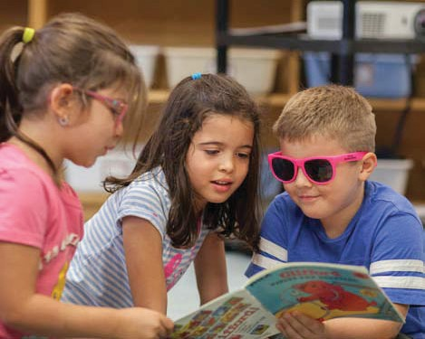
For more information, please contact your local CAS or the following link: www.children.gov.on.ca/htdocs/English/childrens aid/reportingabuse/abuseandneglect.aspx

Personal Belongings
Program Information
Items that are brought into a program from home must be labelled with the child’s name. Please be advised that the YMCA is not responsible for any lost or stolen items.
Your Child’s Toys
Our centres have a variety of age-appropriate toys and activities for your child to enjoy, and children are encouraged to share as part of their learning experience. We ask that children keep their personal toys at home. Designated ‘Show and Share’ days allow your child to bring in a special toy from home on that day to talk about and share with their peers.

What to Bring?
You will need to supply the following:
Infant/Toddler
- 2 complete changes of clothing
- Seasonal outdoor clothing
- Lightweight and breathable blanket for rest time
- Diapers and wipes
- Bottles/sippy cups
- Refillable water bottle
- Formula or expressed milk if your child has not transitioned to 2% milk. Health Unit recommends 3% for children under two years
- Sunscreen
- Appropriate indoor footwear (flip flops and crocs are not considered safe for play)
Preschool
- 2 complete changes of clothing
- Seasonal outdoor clothing
- Blanket for rest time
- Pull-ups and wipes
- Sunscreen
- Appropriate indoor footwear (flip flops and crocs are not considered safe for play)
- Water bottle
School-Aged
- Complete change of clothing
- Seasonal outdoor clothing
- Backpack or gym bag
- Appropriate indoor footwear (flip flops and crocs are not considered safe for play)
- Hat
- Refillable water bottle
- Nut-free lunch*
- Sunscreen
- Insect Repellent (Optional)

*On PD Days, please provide your child with a nutritional nut-free lunch. The YMCA provides all food for the morning and afternoon snack, unless you specify a special diet for your child. Special hot lunch days will be communicated prior to the PD Day or School Breaks.

Fun Can Be Messy
Even the oldest children can get wet during water play, or cover themselves in paint. Although all paints and markers in our centres are washable, we suggest children wear comfortable, washable clothing you wouldn’t worry about being spoiled.

Keep an extra set (or two) of clothing at the Centre for your child. This extra set should change seasonally, and as your child grows. We are careful about looking after each child’s personal items, however we cannot be held responsible for loss or damage to items left at the Centre. Please leave all sentimentally important toys and belongings at home.
Well-Being
Program Information
Illness in group settings is often unavoidable. If your child shows symptoms of ill health such as fever, vomiting or diarrhea, your child will not be admitted to care. In the case of discharge from eyes or ears and rashes unknown by staff, a physician’s note may be required stating the nature of the illness and that the child is cleared to return to group care. If your child develops symptoms of ill health while in our care, you will be contacted to pick-up your child. In order for children to attend care they must be well enough to go outside and participate in all aspects of the program. Exclusion periods vary per illness. Please speak to the supervisor or refer your local health unit guidelines to determine when your child can return to care.

Head Lice
Head lice and nits is usually present in our community at any given time. To child care centres and schools, this nuisance is usually more prevalent after each major school break: after summer/winter holidays and March Break.
Throughout the year, spot checks will be conducted on children and staff. If a child has either nits or lice, contact will be made to immediately have the child picked up. The child must then be treated and all nits must be removed prior to admittance to the program. There are no exceptions to this policy in order to ensure the lice is contained to be best of our ability. Your cooperation is greatly appreciated in this matter.
Chronic Illness and Children with Medical Needs
When a child is under a doctor’s care that requires on-going medication or treatment, it is considered a ‘chronic illness’. Illnesses such as allergies, asthma, diabetes, epilepsy, etc. are considered chronic; which simply means the child requires ongoing care. In most cases, children with chronic illnesses attend YMCA programs with no difficulties. However, it is up to the supervisor and manager to assess the child’s chronic illness at the time of registration or when the illness has been identified to ensure the YMCA is able to manage the illness and/or condition. Parents are required to complete an “Individual Medical Plan” (IMP) in cooperation with or reviewed by the supervisor and signed-off by all staff, students and volunteers prior to their child beginning care.

Infectious and Communicable Diseases
The YMCA follows the Ontario regulations under the Health Protection and Promotion Act. Working with our Local Public Health partners (Sudbury and District, Manitoulin, North Bay, Parry Sound, and Porcupine), the YMCA has developed guidelines for proper disinfection and follows their direction regarding reporting of communicable diseases and exclusion periods from our programs.

Medication**
Prescription medication must be prescribed by a licensed physician or accompanied by a doctor’s note to be administered. Parents are required to complete and sign a Medication Consent form outlining dosage and times to be given. Over-the-counter medication will only be given if accompanied by a note from a licensed physician stating the medication name, dosage and time-frame to administer. All prescription or non-prescription medication must be in the original container, labelled with the child’s name, date of purchase, name of drug, dosage, storage instructions and accompanied with the assigned measuring device.
Please note: parents may sign an authorization for application of ointments and other creams.

**All medication must be given to a YMCA staff member. It can never be left in the cubby area or backpack.**

Anaphylaxis Policy
We strive to minimize the risk of exposure to known allergens to the children in our care. If a child has an anaphylaxis allergen, it is the parent’s responsibility to inform staff of a child’s allergy at the time of registration and update us if any changes occur. Parents are asked to provide and/or complete a detailed “Individual Anaphylactic Plan” (IAP) for their child and to train the supervisor prior to the first day of care. Allergy lists are posted in all program areas, in cooking areas and are attached on educator’s clipboards. An Anaphylaxis Alert Poster is placed at the entrance of the centre/program.
Anaphylaxis Protocol, Nutrition, and Bagged Lunch Policy

Nutrition
Our full day child care programs offer a variety of nutritious morning snacks, lunches and afternoon snacks prepared by an on-site cook or caterer. School-age programs receive a morning and afternoon snack. To ensure that your child receives a well-balanced meal, our menus follow Eating Well with Canada’s Food Guide and are planned in consultation with our Local Public Health partners in Manitoulin, Nipissing, North Bay, Porcupine, and Sudbury, as well as the Ministry of Education. Our weekly menus are posted for your information with any menu changes noted. Infants are fed according to their individual needs in partnership with parents. Any special dietary and feeding arrangements based on written instructions from the parent of the child must be followed. Families are required to provide their own specialty items (including infant formula or baby food). Due to children with allergies and food restrictions, the YMCA requests that certain foods from home not be brought into our programs. These items are posted.
There may be special circumstances where families may wish to bring food, such as celebrations, however, they must be first approved by the child care supervisor.

Nuts and Other Allergens
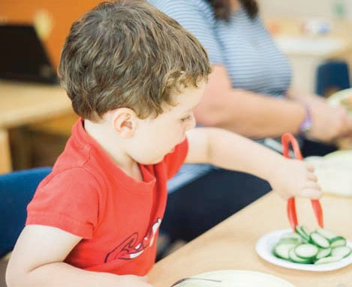
We are a peanut/nut sensitive environment. If you are providing food for your children, please ensure that all food does not contain nor may contain nuts or peanut products. Please check with your child(s) program for a list of food restrictions.
You can also access a copy of the Eating Well with Canada’s Food Guide at
www.hc-sc.gc.ca/fn-an/food-guide-aliment/index-eng.php

Bagged Lunch Guidelines (including Food From Outside)
Anaphylaxis Protocol, Nutrition, and Bagged Lunch Policy
These Guidelines apply to any food item being supplied by the caregiver, outside of the Centre's kitchen and/or caterer.

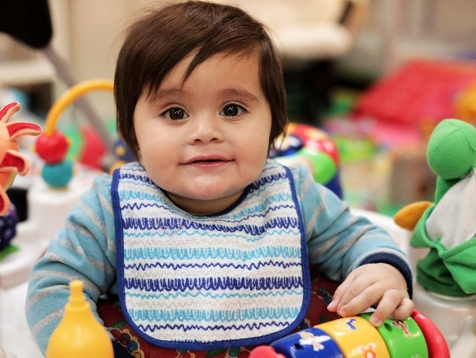
Families are reminded that they are responsible for providing a healthy, nut-free lunch for their child(ren) over the age of 44 months (school-age programs) during any non-instructional full-day attendance, such as PD days, school breaks, and summer programs. All YMCA NEO Licensed Child Care programs offer nutritious morning and afternoon snacks to all participants each day.

Bagged lunches should:
- Follow Canada’s Food Guide
- Be contained in a labelled lunch bag
- Consist of foods that do not contain or have not come into contact with nuts or peanuts
- Contain a refillable labelled water bottle
Here are a few suggestions to create interesting, healthy and delicious peanut/nut free snacks and lunches for your child(ren).
- Breads: Bagels, bagel crisps, whole wheat bread, buns, whole grain crackers
- Fruit: Apple, banana, blueberries, pears, oranges, fruit salad
- Vegetables: Broccoli, carrot sticks, vegetable juice, radishes, cucumber
- Milk and Dairy: Cheese, milk, yogurt tubes, smoothies
- Meats and Alternatives: Cold cooked chicken, hard-boiled egg, tuna, turkey, roast beef, hummus, falafel
- Extras: Dried cereal, muffins, granola mix
Infant Food and Beverages
The YMCA is required to have written instructions from a parent regarding feeding for all children under one year of age. Instructions are to be kept in the child’s file. Baby food should never be fed to a child directly from the jar/container. Transfer the food from the jar to a bowl/plate. Do not save leftover formula, milk, or expressed milk from a bottle that has been served to a child.

Expressed Milk
Expressed milk must be treated like any other body fluids. Safe handling, storage, thawing, and dispensing are required to minimize the risk of illness for children and adults.
Do not microwave expressed milk or formula because microwaves often heat unevenly and scalding can result. In addition, microwaving expressed milk may affect its quality.
If plastic baby bottles (polycarbonate) are used, ensure that the heating of milk or preparation of formula is done in non-plastic containers. Allow the liquid to cool to lukewarm in a non-plastic container and then transfer it to bottles. Heat can break down plastic and cause chemicals such as bisphenol A (BPA) to leak into beverage/food.
You can also access a copy of the Eating Well with Canada’s Food Guide at
www.hc-sc.gc.ca/fn-an/food-guide-aliment/index-eng.php

How to Handle Expressed Milk:
- Wash hands before and after handling expressed milk.
You can also access a copy of the Eating Well with Canada’s Food Guide at
www.hc-sc.gc.ca/fn-an/food-guide-aliment/index-eng.php
Anaphylaxis Protocol, Nutrition, and Bagged Lunch Policy
- Wear vinyl gloves when dispensing expressed milk from one container to another. Wash hands after removing gloves.
- Ensure expressed milk storage containers and bottles are labeled with the child’s name, name of child’s mother, and date breast milk was produced.
- Expressed milk must be kept refrigerated at 4 degrees C (40 degrees F) or lower and separate from other foods (e.g. plastic container with lid) until served.
- Discard any leftover expressed milk in bottle/cup after child has finished drinking.

Children drinking expressed milk need to be supervised closely to prevent sharing with other children. If a child drinks expressed milk intended for another child, contact Public Health for guidance and inform the parent of the child who drank the breast milk.
Weemarkable
Weemarkable App
We’re making it easier for our YMCA Preschool Child Care families to connect to the small moments and big milestones of their child’s day, through our YMCA app – Weemarkable. Weemarkable is the window into your little one’s day - from wherever you are. It’s the app you love to get notifications from - as you receive messages and photos sharing in their excitement and fun. It keeps your mind at ease with the ability to access important child care notices, photos, milestones, educator observations, menu information and direct to educator messaging with just a tap. And most importantly, even when you can’t be with them, it’s Weemarkable how connected you’ll be. Please speak to your supervisor and enrol in Weemarkable today.

It’s the app you love to hear from...
- Follow all your children registered in YMCA Preschool Child Care on one feed
- Direct messaging to and from your child’s educators
- Review your child’s weekly menu
- Daily educator observations about their play, nap and meals
- Integrated with YMCA Playing to Learn Curriculum
- Important notifications, such as centre closures due to weather, sent directly to your mobile device
- Photos of your child engaged in learning
- Add additional followers, such as grand parents, to your child’s profile and customize the content they can view Completely safe and secure

YMCA Child Care families can access it free for Apple and Android devices.

Outdoor Play
The YMCA strives to make outdoor play safe, adventurous and fun for all children. We follow the Child Care and Early Years Act which requires that children who are enrolled in full day care have two hours of outdoor play each day, weather permitting. Before and after school programs have 30 minutes of outdoor play each day. Please ensure that adequate clothing is provided so that your child can participate comfortably in these daily outdoor activities.
Program Information
Extreme Weather
During extreme weather alerts, including, cold, heat, smog, wind chill advisories children will not participate in the outdoor program and an alternative indoor plan will be implemented.

Sunscreen Policy
Parents are asked to provide personal sunscreen from home. Each full day program uses sunscreen with SPF of 30 or higher that offers UVA and UVB protection for all children over one year of age. This will be applied both morning and afternoon during the summer months. Sunscreen from home must be nut free and labelled with their child’s name.
West Nile Protocol
Human illness from West Nile virus is rare, even in areas where the virus has been reported. In accordance with our Local Public Health partners (Manitoulin, Nipissing, North Bay, Parry Sound, Sudbury, and Timmins),the YMCA is taking this health situation seriously. From May 1st until September 31st, a YMCA staff may apply insect repellent that you have provided upon written consent.

Off-Premises Activities
Throughout the year, trips are made available based on the interests of the children. A permission form will be given to parents outlining the planned destination, method of transportation, time, date and learning objectives. These forms must be signed and returned to your child’s educator in order for your child to participate. Children participating in off-site activities are supervised by an adult at all times. Furthermore, students or volunteers are never counted in ratios or left alone with a child or a group of children. Parents and/or family members are welcome to volunteer for their child’s planned trips. Please contact us if you would like to do so.

Please note: All volunteers for field trips must be 18 years of age and provide a Current Health Assessment and Up-To-Date Immunization Record. Prior to volunteering, they are required to obtain and submit a Police Records Check (Vulnerable Sector), current within six months and/or sign a declaration for special occasion volunteering.

Emergency Management
The YMCA has developed clear policies and procedures for emergency management. If our child care centre is located in a school, the YMCA adopts the schools emergency management procedures.

Our staff roles and responsibilities are clearly outlined in the event of an emergency, the most important being that staff will ensure that children are kept safe, are accounted for and are supervised at all times during an emergency situation.

All YMCA staff, students and volunteers are required to sign-off on the “Emergency Management Plan for Child Care” annually and when changes are made.

If an emergency occurs, every attempt will be made to contact parent(s). If they can’t be reached by telephone, parents will be informed by local radio/television stations, our website, Weemarkable and/or social media postings.
Program Information

The YMCA conducts monthly and annual emergency drills so that the children and staff are well-prepared in the event of an emergency.

Safe Schools Act
The Safe Schools Act, 2000 puts into law various ways to increase safety, respect and responsibility in Ontario schools. Mandatory suspension or expulsion includes all school related activities, including the YMCA Program. If a discretionary suspension is given to the student, the principal will determine if the student is fully suspended from all school and school-related activities, including the child care program.

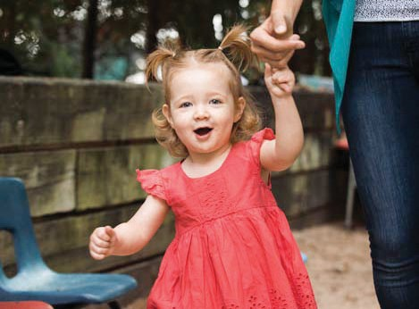
Smoke Free Policy
YMCA Child Care programs are smoke-free. Smoking or handling a cigarette or tobacco on YMCA premises including all indoor and outdoor areas is prohibited under the Smoke-Free Ontario Act, 2005. Failure to comply could result in a penalty of up to $5,000.00.

Water Safety Guidelines
Sensory exploration is an integral part of the YMCA curriculum. A part of sensory exploration is the use of water play tables, splash pads, sprinklers and hoses. When these items are used, a staff member must be positioned directly in the area of play. If no other outdoor play activities are taking place at the same time, all staff members are expected to supervise the water play activities. Portable wading pools are not to be used for water-based activities.

When visiting a regulated public pool, the YMCA supervisor must ensure that the following is in place:
- A qualified lifeguard is on duty at all times
- Rules and regulations of the public pool are followed
- Children are directly supervised by an adult (18 years or older) at all times
- Parents are advised and have signed-off permission for their child to participate in the field trip.

Parent Partnership
Parents are encouraged to participate in the program whenever possible. Parental involvement is a key element to the success of your child’s experience in YMCA Child Care. Participation can include verbal or written feedback, sharing information about your child’s development, attending meetings or events.

In addition, the YMCA sends out an Annual Family Survey to help provide us with feedback to ensure that we are providing your child with the best possible care. The surveys are shared with the educators to give them your positive feedback and/or recommendations.

Resolving Parent Issues and Concerns
YMCA staff are dedicated and committed to connecting, partnering, and engaging parents to provide the best possible care for each child. Daily conversations benefit the child, family, and the staff and help provide consistency to understand the child and plan for their success. These daily interactions provide families and the educators an opportunity to discuss their child’s progress and any concerns or challenges.
Addressing Parental Concerns

In these situations where an issue or concern arises, the YMCA takes these concerns very seriously and will together work with the family as a YMCA team to reach a resolution in a timely, confidential, fair, respectful manner in keeping with our YMCA Core Values. All parent issues or concerns are taken seriously and will be responded to within a 24-hour time frame of being advised.

Steps for Resolving Parent and/or Guardian Issues or Concerns
Every effort will be made to resolve issues or concerns with the Educator, Centre Supervisor or Program Manager. The person who raised the issue will be contacted, the issue or concern will be reviewed, and the YMCA will outline the findings and will explain how the YMCA proposes to resolve the issue/concern to the mutual satisfaction of both parties whenever possible.

The YMCA recommends the following process to help resolve a concern or issue:
- Speak to the educator/staff person involved;
- If unresolved, speak with the program supervisor;
- If unresolved, contact the Program Manager;

- If unresolved, contact the Vice President of Child, Youth & Family Development;
- If unresolved, contact the Chief Executive Officer; or
- If still unresolved, contact the Board Chair. The contact information for the above-persons is available at each child care and school-age program.

Possible Nature of Issues or Concerns and Steps for Parents to Report
Program Room-Related
(E.g.: sleep, feeding or diapering, toilet training, daily activities, etc.)
- Bring forward your issue or concern to the educator directly or the supervisor.

General, Centre or Operations
(E.g.: child care fees, hours of operation, staffing, waiting list, menus, etc.)
- Bring forward your issue or concern to the supervisor and/or Manager.

Concerns about a YMCA Educator or Supervisor Conduct
- Bring forward your issue or concern to the individual directly or to the supervisor.
- If it’s concerning the educator, then the supervisor or management will address the issue or concern.
- If it’s concerning the supervisor, the issue will be addressed by management or the Vice President of Child, Youth & Family Development.

Student/Volunteer-Related
- Bring forward the issue or concern to the educator responsible for supervising the volunteer or student or the supervisor.

Important: All issues or concerns about an educator, student or volunteer’s conduct that puts a child’s health, safety and well-being at risk should be reported to the supervisor immediately.
Addressing Parental Concerns
Steps for YMCA or Staff in Responding to Issue or Concern
- Address the issue or concern at the time it is raised; or
- Arrange for a meeting with the parent/guardian within 24 hours.
- Document the issues/concerns in detail (YMCA Incident Report):
  - Date and time issue received;
  - Name of person who received it;
  - Name of person reporting it;
  - The details of the issue/concern; and
  - Any steps taken to resolve it and/or information given to the parent regarding next step
- If the person being notified is unable to address the matter, provide contact information for the appropriate person.
- Ensure the issue/concern is investigated by the appropriate party within 24 hours or as soon as reasonably possible thereafter. If delays, document reasons in writing.

- Provide a resolution or outcome to the parent/guardian who raised the issue/concern

Concerns about Suspected Abuse, Neglect or a Disclosure
Concerns about suspected child abuse, neglect or a disclosure is reportable to the local Children’s Aid Society. Everyone, including the members of the public and professions working closely with children is required by law to report suspected cases of abuse, neglect or a disclosure. If a parent or guardian expresses that a child is being abused or neglected, that person will be advised to contact the local Children’s Aid Society directly. The YMCA also has a legal duty to report once informed, or if a staff, student or volunteer suspect child abuse, neglect or there is a disclosure.

Escalation of Issues or Concerns
If after the above-noted processes have been tried and fair resolution to the mutual satisfaction of both parties, the YMCA would encourage parents and/or guardians to contact the Ministry of Education, Child Care Quality Assurance and Licensing Branch or any of the relevant regulatory bodies where they see their issue or concern may fall, such as, but not limited to; the local Children’s Aid Society, local Public Health, local Police, The Ministry of Environment, local Fire Department, The College of Early Childhood Educators, The Ontario College of Teachers, The College of Social Workers and/or the local Municipality for Children’s Services.

Each program has the contact information of the above-noted regulatory bodies.
“The YMCA Playing to Learn is a curriculum guide built on the importance and value of play for young children. The document makes, and backs up, arguments of why and how children’s play is essential to the healthy social, physical and cognitive development of all children.” Martha Friendly, Executive Director of the Childcare Resources and Research Unit
YMCA Curriculum

YMCA Curriculum Goals & Approaches
1) Promoting Health, Safety, Nutrition, Well-Being and Inclusiveness:
Keeping children healthy and safe is a priority at the YMCA and we understand that the well‐being of a child is a parent’s # 1 concern. Therefore, we have developed comprehensive, research-based procedures to support children. Some of the procedures in place at the YMCA include:
- Safe supervision of children,
- Working with community agencies to support ISP,
- Child protection procedures and training,
- Sanitation and disinfection procedures,
- Menu planning following the Canada Food Guide, Ministry of Health and Health Unit recommendations,
- Communicable disease prevention,
- Emergency procedures,
- Standard First Aid and CPR/C training

2) Supporting Relationships:
At the YMCA, we understand that young children flourish in all areas of development when they are in positive and responsive relationships with adults. YMCA Educators build a foundation of trust with children by being available, sensitive, responsive, and caring. We work alongside community agencies to ensure all children are supported through individual program plans.
YMCA educators create an inclusive and respectful environment to foster positive, equitable, and collaborative relationships. When children feel safe, secure, valued and a contributing member of their world they are able to explore, discover, try new things, grow, learn and develop. To support your child's care, growth and development, YMCA educators interact and communicate with parents on a daily basis sharing observations, documentations, and reflections.
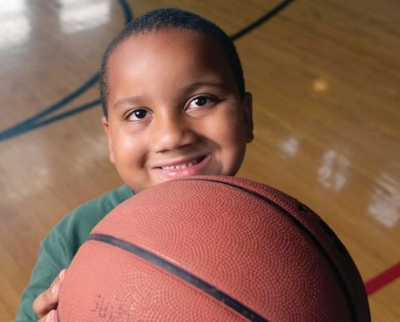

Gross Motor Skills
Learned actions involving the large muscles of the body. (E.g. kicking a ball)

Fine Motor Skills
Learned actions involving the small muscles of the body, including the hands, mouth and feet. (E.g. cutting with scissors)

Self-Regulation
The child’s conscious or unconscious control of their body, relationships and other aspects of him or herself.

Resilience
The ability to recover quickly from difficulties.

Well-Being
The state of being comfortable, healthy, or happy.

Responsive Caregiving
The process of offering consistent, reliable care via careful observation of cues.
3) Encouraging Children to Interact, Communicate, & Self-Regulate:
YMCA Curriculum
The YMCA believes that it is the role of the adult in a child’s life to support them to learn how to interact effectively with the world around them including other children, adults, and the environment.

Generally self-regulation involves gaining a degree of control over one’s bodily functions and impulses, managing one’s emotions, changing one’s behaviours and maintaining focus or attention on something or someone.

“The better a child can stay calmly focused and alert, the better he integrates the diverse information coming from his different senses, assimilates it and sequences his thoughts and actions.” (Shanker 2012)

“Caring consistent relationships with adults, provide external supports that serve as the basis for developing self-regulation.” (Gillespie & Seibel 2006)

Some of the approaches implemented by YMCA Educators to set the stage for positive interactions among children include:

- Educators provide small group experiences that allow for more individualized adult attention,
- Educators role model inclusive, respectful, and collaborative interactions with children and other adults,
- Educators ensure the learning environment is flexible so they can respond in the moment and build on or scaffold the children’s interests,
- Educators ensure toys, equipment and materials are plentiful and available to children at all times,
- Children are given freedom to make choices,
- By engaging as a play partner with children, educators are able to demonstrate pro‐social skills including promoting discussion, problem solving when conflict arises and understanding how their actions affect others, and
- Educators attend trainings that address self-regulation and resilience.
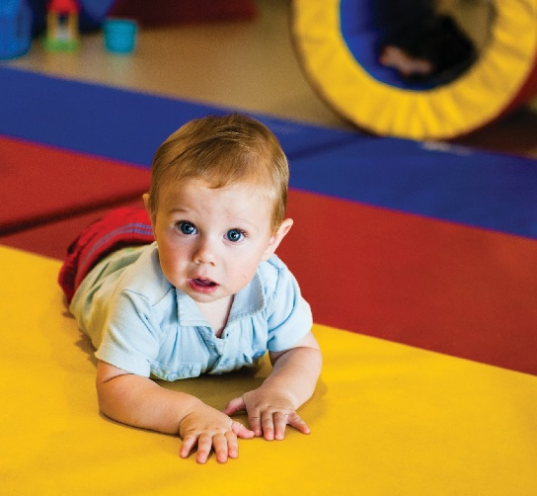

Discover
To find something unexpectedly.

Observation
The informal or formal perception of an individual or group of people, or the perceptions gained from looking at an environment or object.

Documentation
The process of observation, data collection, careful analysis and reflection resulting in display that is an integral part of a play curriculum.

Reflective Practice
The capacity to reflect on action so as to engage in a process of continuous learning.

Strategy
A plan or method of achieving a goal.

4) Fostering Exploration, Play & Inquiry:
YMCA Curriculum
Children are born with a natural sense of curiosity and wonder. They play naturally. As parents and educators, we watch children explore their world through their senses, repetition of tasks, imitation, asking questions, pretending. But what are children really doing? Children are putting together all the pieces of how the world works through exploration, play and inquiry.

YMCA Educators understand the importance of play. They foster, expand and scaffold this natural talent called “play” by being:
- Active participants,
- Architects of the play space,
- Keen observers & reflective practitioners,
- Planners & reporters, and
- Collaborators.

Observing a day-in-the-life of a YMCA Child Care program, you will note that the majority of activities are directed by the children. Children decide where, when, what and how they wish to play. Their decisions are based on their interests and curiosity. The educator responds by adapting the environment by adding new toys, materials and equipment, posing questions, and being a play partner. This sets the stage for further play, inquiry, discovery and learning. The educator’s role is to support play so that learning and development flourishes.

For example, an initial interest in bugs was scaffolded for two weeks and extended into the interest of insects and worms. In the environment, we would see the evolution of the interest identified on the program plans and linked with documentations. Whatever the children currently know about bugs, insects and worms is enhanced when the environment is transformed to promote independent and co-learning opportunities. A butterfly cove and ant farm could be set up to stimulate conversation and respect for nature while building on their existing knowledge new information is provided. Upon invitation to play, the educator becomes a play partner to promote inquiry and discovery following the child’s lead.
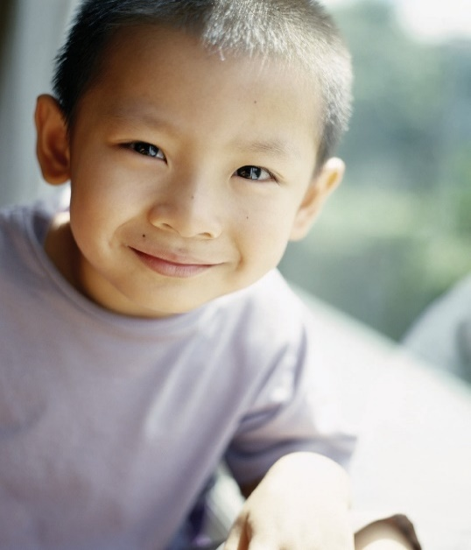

Role-Modeling
Demonstrating appropriate behaviour that can be seen by the children so that they can observe and internalize what they see; showing how a particular role is conducted.

Scaffold
The role of the adult (or more mature child) in providing a mental bridge to support a child’s learning.

Pro-Social Skills
Learned behaviour that demonstrates empathy, esteem, honour and consideration to another person.

Curiosity
Mental interest that leads to behaviours of discovery and learning.

Inquiry
The act of asking questions in order to gather information.

We may investigate the parts of an ant, grab our magnifying glasses and head outdoors on a special adventure searching for bugs. As we scaffold learning by studying life-cycles of caterpillars and bees, we might extend it to include plants and trees. When we interact with the children, we introduce new vocabulary and experiences related to their interests. The activities provided in the math centre could allow opportunities to compare and classify things that grow from seeds. Planting seeds could lead to a hypothesis regarding how long it will take to grow and they might create a graph to chart the growth. The spontaneous exploration will occur naturally, and the educator will respond by being a keen observer, recorder, modeller and responder.
YMCA Curriculum

5) Providing Child-Initiated & Adult-Supported Experiences:
Children and parents are warmly greeted upon arrival and after a brief check‐in to share news from the evening before, the children get down to the serious business of playing.

The room is set up with a variety of activities that support the observed interests of the children. The children might join some friends at the creative art table to work collaboratively on a collage, or they might work on a Lego structure they safely stored on the counter to complete the next day.

There are no expectations imposed by the educator or curriculum on where children play, or whom they play with, or how long they play at one activity. That is for the child to choose based on their interests.

You may overhear a small group of children in the dramatic play centre dressed in costumes acting out a scene of being “mama, papa, and baby at the doctor”. The educator has been assigned the role of “doctor” by the children and takes this opportunity to ask the children questions that expand their understanding of what happens at a check‐up.

Tomorrow the educator supports the children’s interest by adding books about doctors and hospitals to the dramatic play centre hoping to build on the children’s interest and spark more questions and play; resulting in more learning.
Child Directed Play
Spontaneous activity initiated by the child that is allowed to take the course decided upon by the child; may involve careful adult planning.

Play Partner Relationship
One or more individuals playing together with a shared interest; in the case of adult-child play partnership, the adult allows the child to take the lead.

Dramatic Play
Sustained pretend play in which the child acts out a role using movement and props.

Child Centered Education
A philosophy of childcare and education that emphasizes the importance of the child’s need to direct his own activity, to make play choices spontaneously, and to learn at a self-determined level.

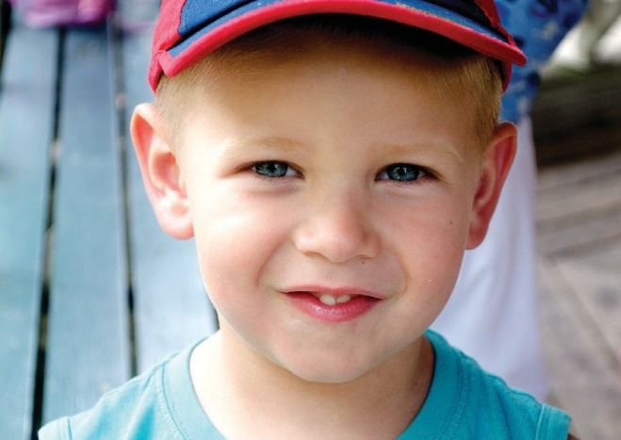
6) Planning Learning Environments to Support Every Child’s Learning:
YMCA Curriculum
YMCA Child Care programs are located in a variety of facilities including schools, community centres, and YMCA-owned buildings.

At the YMCA we understand that the parent is the child’s first teacher, the YMCA Educator is the second teacher and the learning environment is the child’s third teacher.

The YMCA’s unique approach to planning and creating learning environments supports children’s play so that early learning and healthy development is maximized.

YMCA learning centres are designed to be flexible and responsive to the needs of the children.

We have created home-like environments that include calm colours, soft furnishings, and items from nature like: plants and pets, photographs and accessories that are intended to make children feel comfortable and safe.

YMCA Educators understand that children learn holistically not in one area of development at a time. We understand that riding a tricycle involves gross motor and fine motor skills, but the play children engage in while riding a tricycle involves many more - communication skills, social skills, etc.

Therefore, you may find books, paper and crayons in the block area because children are using these items to figure out how to build a bridge from one shelf to another. Or you may find play dough in the dramatic play area where children are making pizza. And on a beautiful day you may see indoor furniture move outdoors to take advantage of the weather.

Planning
The act of preparing and designing experiences and activities (in this instance in accordance with YMCA curriculum).

Environment
Aspects of the immediate surroundings including the delineation of space, the presence or absence of objects, furniture, light, colour, toys and play things and the inclusion/exclusion of indoor and outdoor space.

Learning Centres
Specially prepared places where materials are provided to respond to children’s interests or trigger new ones; spaces for learning in content specific areas; discovery or inquiry-based spaces designed by educators for small groups of children.

Play Materials
Any found items or purpose-made manufactured items that are used for props, for creative enterprises or construction.

Whole Child
A concept of the child that sees all developmental domains as interacting, the child being more than the sum of domains.

7) Incorporating Indoor, Outdoor, Active, Rest & Quiet Activities:
YMCA Curriculum
YMCA educators design a daily schedule that meets the needs of the children and provides for a balance of activities throughout the day.

Consideration for the care requirements, age, developmental level, energy level, and interests of the children are included.

Generous blocks of time for children to explore, play, and inquire are included both indoors and outdoors.

The daily schedule is not rigid and is designed to operate in small group settings wherever possible. One small group of children may be on a walk in the community, while the other small group may prefer to stay indoors and make playdough cookies.

Periods of active and quiet play are interwoven throughout the day both indoors and outdoors.

Outdoor play is to be included as part of the daily program. All children attending for more than six hours per day will be involved in a minimum of two hours of outdoor play, weather permitting (1 hour outdoors at a time is the maximum for infants). For before and after school children, a minimum of one half hour period outdoors per day is required.

At the YMCA, we don’t let the weather stop us from having fun in nature. The children love to bundle up in warm dry clothes and head out to jump in puddles or make snowballs. In very poor weather, active play takes place indoors so that children get the physical activity their bodies require.

YMCA educators are trained to keep transitions from activity to activity to a minimum so children get to play more.

However, young children thrive on regular schedules and feel secure when they can predict what will occur throughout the day; therefore snacks and meal times are consistent as is the rest period in the afternoon for young children.
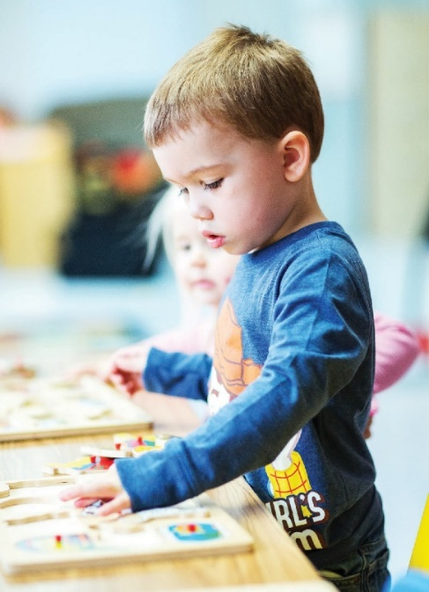
Transitions
Aspects of the planned and unplanned day that create changes from one type of activity or event to another.

Family
A number of people who decide to live together or who are bonded by birth-ties, who share a home and who share common values and similar lifestyles; adults taking on a parental role and one or more children living and functioning as a unit.

Engagement
Time spent paying attention to something or someone.

Communication
The two-way process of sending and receiving information to reach a shared understanding.

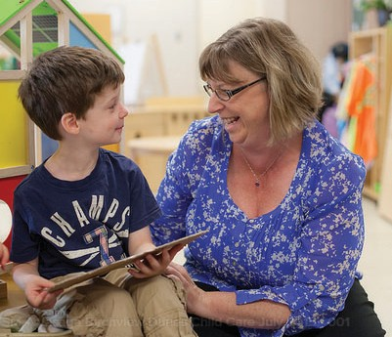
8) Child Guidance:
YMCA Curriculum
All educators, volunteers and placement students will follow our
core values of caring, inclusive, responsible, honesty, respect and collaborative. They will ensure that every child has a sense of belonging, is developing a sense of self, health and well-being, every child is an active and engaged learner who explores their world with body, mind and senses and is a capable communicator who expresses themselves in many ways. Educators support children in developing strategies to remain calm and to regulate their emotions while recognizing the effects of their actions on others.

Any practice based on a negative control technique is not part of the YMCA Child Guidance Practices and Core Values and will be addressed promptly with the supervisor and documented accordingly (following our “Monitoring Compliance and Contraventions” Procedure).

The following Prohibited Practices that put children at risk or inhibit their growth, self-esteem and healthy development are unacceptable:

- Corporal punishment of any child in our care;
- Physical restraint of a child, such as confining a child to a highchair, car seat, stroller or other device for the purposes of discipline or in lieu of supervision, unless the physical restraint is for the purpose of preventing a child from hurting himself, herself or someone else, and is used only as a last resort and only until the risk of injury is no longer imminent;
- Locking the exits for the purpose of confining a child, or confining a child in an area or room without adult supervision, unless such confinement occurs during an emergency and is required as part of the YMCA’s emergency management policies and procedures;
- Use of harsh or degrading measures or threats or use of derogatory language directed at or used in the presence of a child that would humiliate, shame or frighten the child or undermine his or her self-respect, dignity or self-worth;
- Depriving a child of basic needs including food, drink, shelter, sleep, toilet use, clothing or bedding; or
- Inflicting any bodily harm on children including making children eat or drink against their will.

Child Protection
Everyone, including members of the public and professionals who work closely with children
share a responsibility to protect children and vulnerable persons from harm. The YMCA recognizes its responsibility to promote safe environments and practices to protect children and vulnerable persons.

YMCA Educators are trained to recognize the indicators of neglect and abuse and are legally required to report any suspicions that a child may require protection. The role of the child protection agency is to investigate and determine if there is any proof of abuse or neglect and implement supports for the child and their family. It is important that YMCA educators ensure all reports are kept confidential, including only discussing with the family that a report has been made if the child protection agency authorizes them to do so.

9) Process for Monitoring Compliance and Contraventions
YMCA Curriculum
The following processes are in place to monitor compliance and contraventions:

Monitoring:
- Supervision of program areas on a regular basis conducted by supervisor or designate.
- All YMCA educator’s interactions and observations are monitored three (3) times per year (or as required) to ensure they:
  - Provide constant supervision of all children;
  - Use appropriate voice-tone;
  - Provide positive verbal reinforcements (feedback);
  - Respond to children in a gentle and welcoming manner;
  - Are positive role models for the children;
  - Establish and maintain control of their playspace, and
  - Show a genuine enjoyment for their educator role.
- YMCA Full Day & School-Age Quality Assessment Tool is a monitoring tool used three (2) times per year to ensure we continue offering high-quality educational care and programming designed to promote all areas of healthy child development while building on social strengths and overall well-being in our programs.
- Annual Performance Assessment Plans for all staff include Coaching/Mentoring Documentation Forms and Collaborative and Inquiry Forms.
- Scheduled and spontaneous coaching and mentoring conversations with all staff occur.
- External Agency reviews and audits (Quality Assurance, YMCA Play in Action, A Place to Connect, Health and Fire Inspections, Ministry of Education annual license reviews, etc.).
- Discussion pertaining to child care policies occurs before starting work or placement, as part of the orientation process, and occasionally as needed for review at staff meetings and with individual educators/cooks throughout the year.

The Ministry requires a thorough knowledge and policy review of the following procedures:
- Anaphylaxis, Emergency Management Procedures, Evacuation & Lockdown, Fire Safety, Individual Anaphylactic Plans (I.A.P.), Individual Medical or Support Plans (Medical or Specialized Needs), Medication, Playground Safety, Police Records Check (Vulnerable Sector), Program Statement & Implementation (includes Prohibited Practices and Process for Monitoring Compliance & Contraventions), Procedures for addressing with Parent Issues or Concerns, Ratios and Group Sizes, Sanitary Practices, Serious Occurrences, Sleep Supervision, Staff Training & Development, Supervision of Volunteers and Students, Waitlist Procedure., and COVID-19 Policies. The YMCA maintains sign-offs for all staff, volunteers and students to verify compliance.
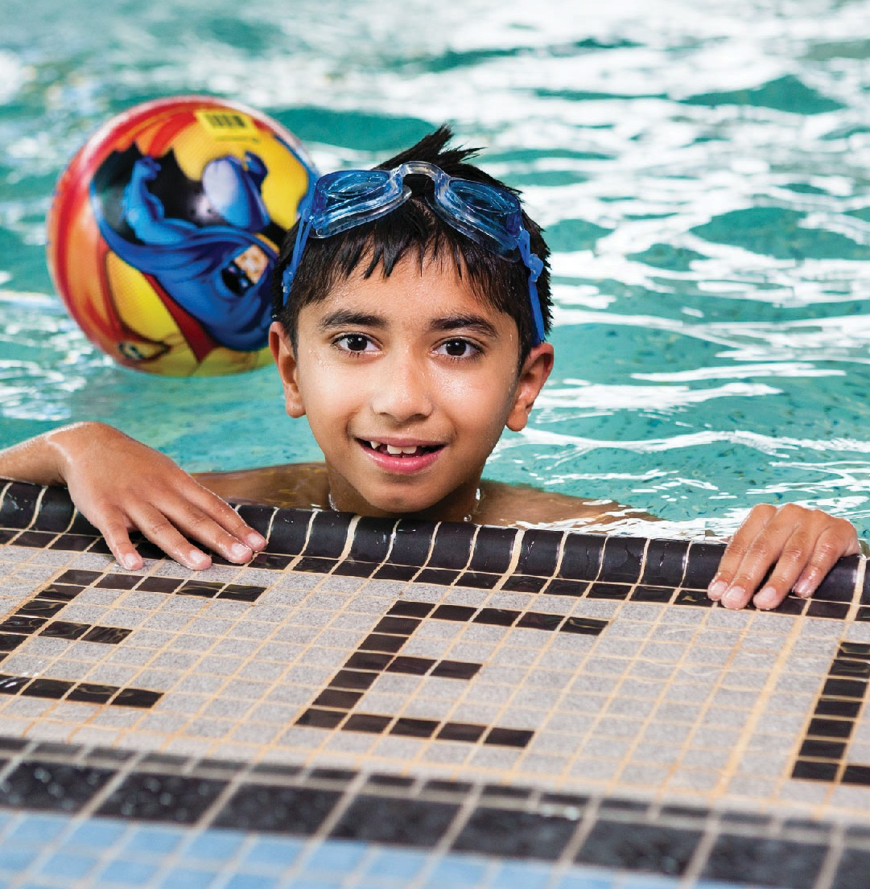
Measures Used to Deal with Contravention of Policies and the Use of Prohibited Practices:
YMCA Curriculum
- Performance goals include full compliance regarding all YMCA Policies and Procedures. Supervisors conduct pre-licensing checklists a minimum of 1 month prior to a license expiry date and use the Compliance Action Plan provided by the Ministry. Staff, students and supervisors will all be included in compliance action plan items through assisting with the development of an action plan or fulfilling action plan details in their role. These
checklists and action plans will be reviewed with the manager for further processing if required.
- Any reports involving breach of the above prohibited practices and all YMCA Child Care Policies or Procedures are taken seriously and will be addressed with YMCA Management and our Human Resources Department.
- Individuals who violate the prohibited practices and this procedure are subject to disciplinary and/or corrective action up to and including termination of employment or volunteer assignment.
- Communications will occur with all appropriate governing agencies as required throughout the process (example: Ministry of Education, Employment Standards, Police, College of Early Childhood Educators, Ontario College of Teacher’s, Children’s Aid Society, etc.).
- Human Resources and Child Protection Policies are reviewed upon hire and annually thereafter.

10) Fostering Engagement & Communication with Families:
At the YMCA we understand that a parent is the most important person in a child’s life. YMCA educators play a supporting role with parents or guardians. YMCA educators and parents communicate on a daily basis about children’s activities and health.

YMCA educators keep a record of each infant, toddler, and preschool age child's learning and development in their observations and daily play experience that are available to parents to read each day on Weemarkable.

Getting to know family members is critical and including them in the program helps a child to feel a greater sense of belonging. Other strategies to engage parents include:
- Posting planning documents that include observations of children’s interests and activities introduced by YMCA educators,
- Documentations that describe play and its connection to learning,
- Parent/Educator interviews/collaborative conversations,
- Celebrations & events,
- Parent surveys,
- Displays of children’s artwork, projects and creations,
- Photographs of children at play.

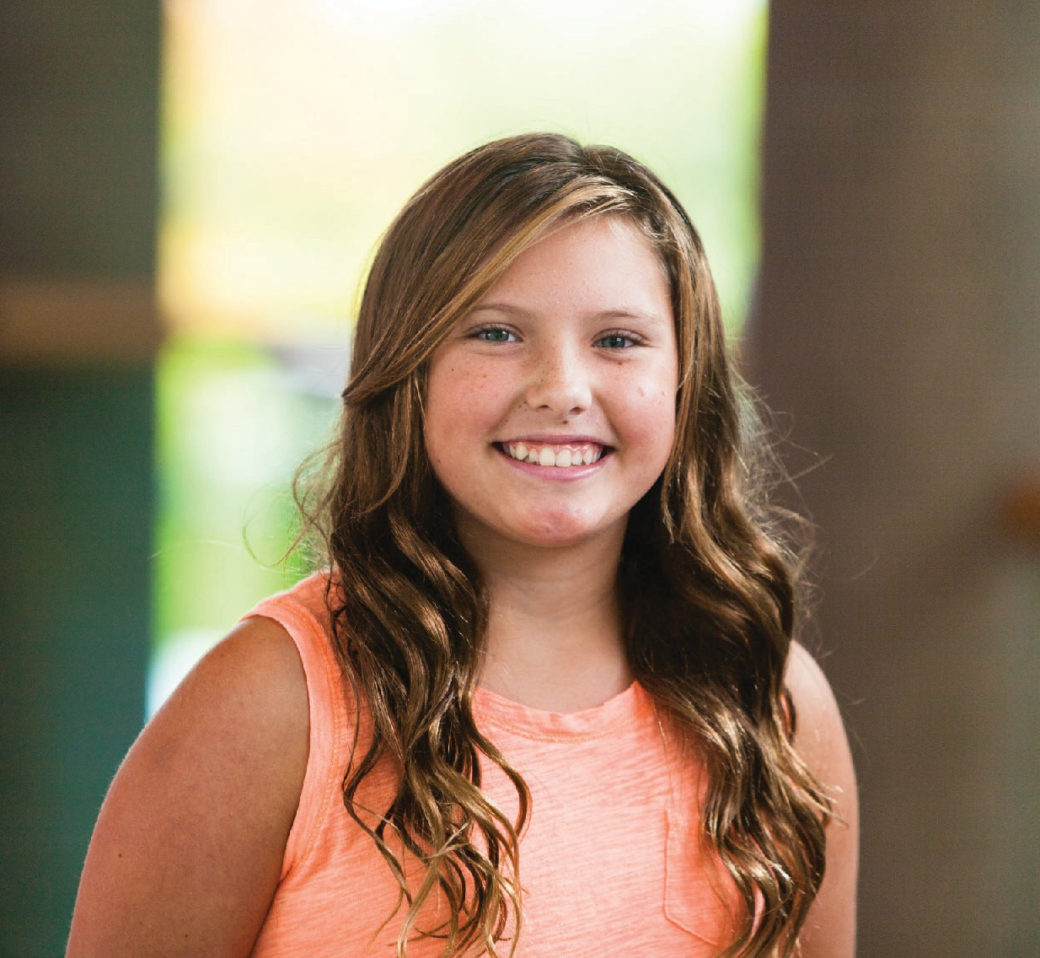
11) Individualized Support Plans and Inclusive Programming:
YMCA Curriculum
Each YMCA centre develops and reviews strategies for dealing with children who have special requirements as each child is different and each centre will have their own particular environment and structures. The YMCA Child Care will ensure that an up-to-date individualized support plan is in place for each child with individual circumstances and includes:
- A description of how the child care centre will support the child to
function and participate in a
meaningful and purposeful manner while the child is in our care;
- A description of any support aids, or adaptations or other modifications to the physical, social and learning environment that are necessary to achieve clause (a); and
- Instructions relating to the child’s use of the supports or aids referred to in clause (b) or, if necessary, the child’s use of or interaction with the adapted or modified environment.
- A plan that is developed in consultation with a parent of the child, the child (if appropriate for the child’s age) and a regulated health professional or other person who works with the child in a capacity that would allow the person to help inform the plan.

12) Involving Community Partners:
While our range of community partners is broad, the largest and most important is the education system. Many of our centres are located in schools, so relationships with principals, faculty and other staff are critical.

The YMCA works closely with local community agencies and partners in order to support the children and families in our programs. We view the community as a valuable resource and our staff plan learning opportunities to engage the community in our programs and we also invite other agencies to provide in-service training for our educators to extend their knowledge and skills.

The YMCA actively seeks out opportunities to share our knowledge and to learn from others in the community through networking opportunities, community planning tables and conferences.

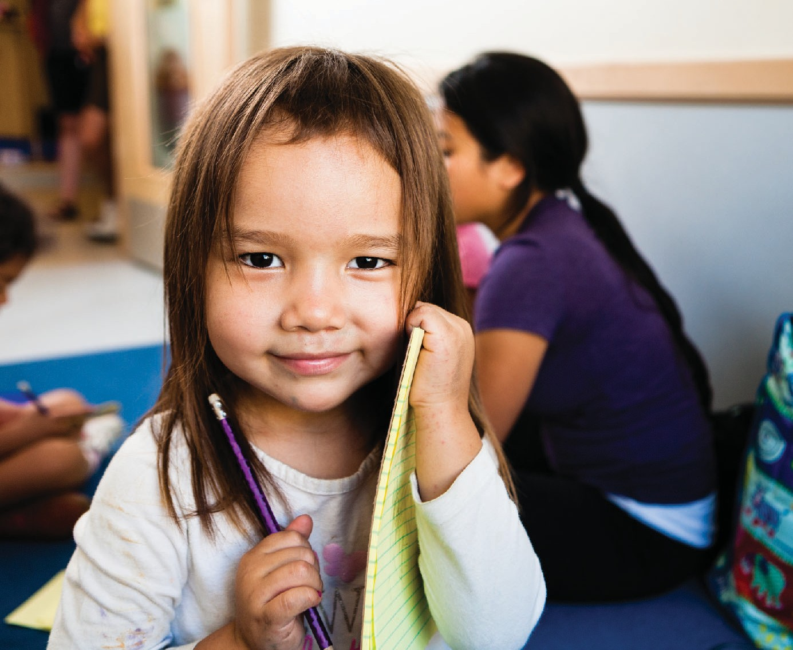
13) Supporting Educators’ Continuous Professional Learning:
YMCA Curriculum
The YMCA is committed to the ongoing professional development of all our educators. What the educator learns will benefit the
children once the information is passed along
and it will reinforce for the educator what has been learned.

YMCA Educators attend a series of YMCA curriculum training sessions throughout their career with the YMCA. Additionally, the YMCA provides opportunities for educators to attend external learning events and conferences. Furthermore, they are required to keep
legislated training requirements like
First Aid/CPR-C certification up-to-date, which means that all
staff are trained and maintain their Standard First Aid, which includes Infant, Child and Adult CPR.

In keeping with the YMCA’s Charitable Purpose, Vision and Core Values, and our commitment to our children and families, the YMCA recognizes and supports the profession of Registered Early Childhood Educators and the College of Early Childhood Educators. While the YMCA recognizes the professionalism of ECE’s rests with the individuals, we believe that championing the standards of practice and code of ethics will have a direct impact on the quality of all child care, which is why we extend these guidelines to all early educators as part of our YMCA Best Practices. Registered ECEs must ensure they are in good standing with the College of ECE at all times.

On a day‐to‐day basis the child care centre supervisor is responsible for the leadership, mentorship, coaching and development of educators. Based on the learning needs of the educators, the supervisor may meet with staff to suggest strategies, conduct learning huddles to focus on a particular area of YMCA curriculum with the entire team, conduct regular staff meetings to reflect and plan, invite speakers from other YMCA departments or community agencies to attend the centre, or provide materials including links, articles, and various readings to supplement educator’s professional learning.

At the YMCA of Northeastern Ontario, our Program Integrity Specialists (Curriculum, Quality Assurance & Professional Development), who are also the Northern Champions for YMCA Playing to Learn, assist the manager and supervisors greatly in all areas of staff training and professional development.
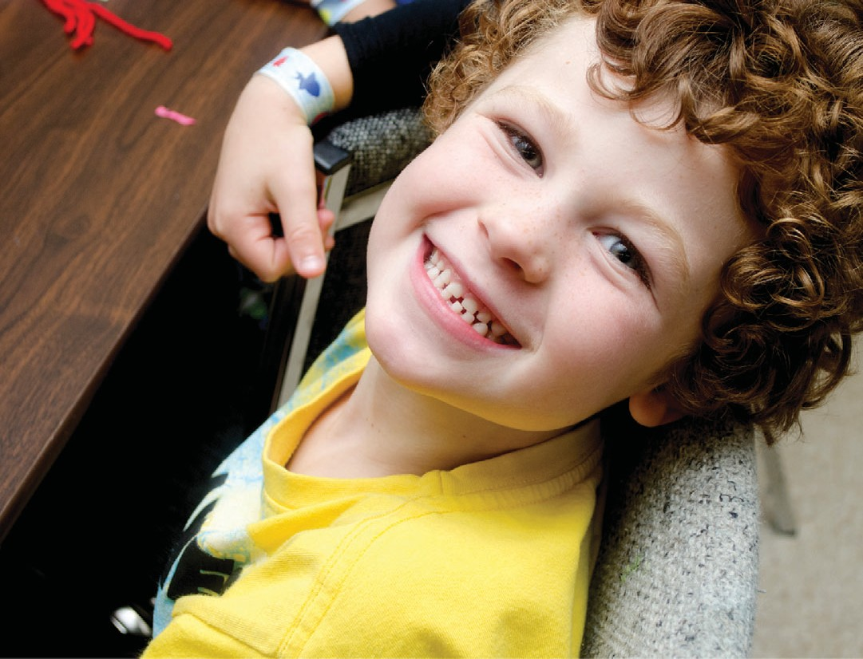
14) Documentation:
YMCA Curriculum
YMCA educators participate in a continuous cycle
of observation:
- Documenting play and its significance
- Determining the children’s interests
- Planning activities that support their interests
- Discussion with team members
- Reflection that informs the planning of activities and the learning environment

Links are made between theory, research, YMCA Curriculum, the YMCA Program Statement, pedagogy and children’s interests to inform the YMCA educators planning.

You will see this cycle reflected in the toys, materials and equipment provided in the play areas, the furniture arrangement, the creative work of children, the activities children are engaging in, on the planning documents posted weekly for parents to read and discuss with the educators, in individual children’s journals and daily reports and in photographs and written descriptions of activities.

This process of continuous program assessment is called reflective practice. On a daily basis educators are observing and engaging with children and evaluating the effectiveness of the learning environment to build on children’s interests. The educators are reviewing the planning process weekly and discussing the environment to look back on what did and didn’t work and then plan for the future. They also meet to ensure they are supporting children’s learning and development through their activities, interactions and play space.

Annual Review
All YMCA educators, volunteers and placement students must adhere to a number of policies and procedures, our Child Care Program Statement including; Ministry of Education, Municipality/DSSAB, Municipal Quality Assurance, Fire and Health Regulations. All educators, volunteers and placement students will review our Child Care Program Statement prior to working in program with the children and annually thereafter or upon substantive changes or modifications.
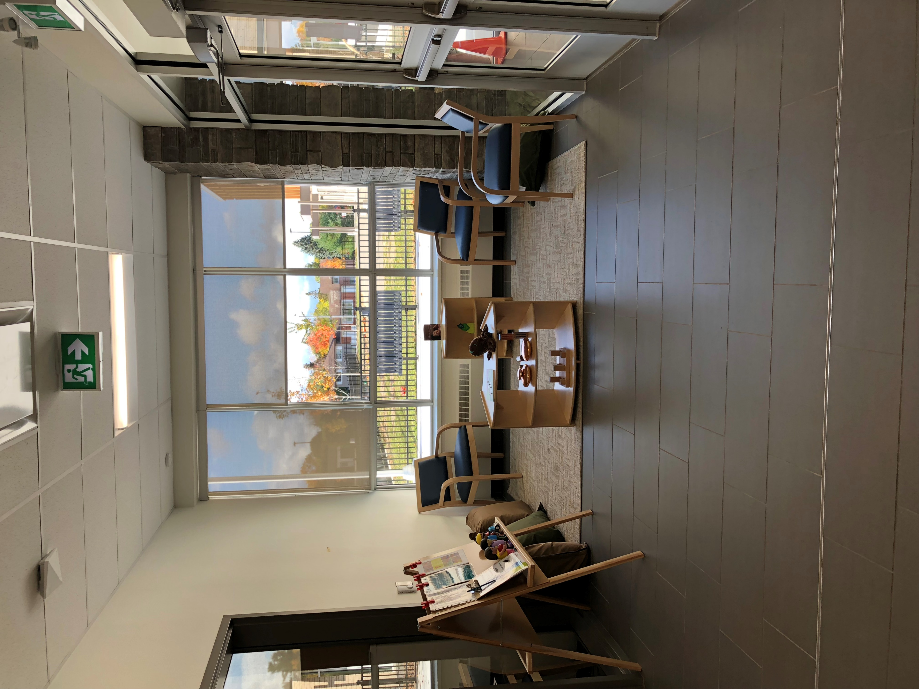

The YMCA of Northeastern Ontario also offers a variety of programs that support the whole family.
Health and Wellness centres are located in North Bay and Sudbury.
The YMCA Employment Centre and Immigrant Settlement Services in Sudbury provides opportunities to assist in career development and outreach services.
YMCA Camps: Rotary's YMCA Camp Tillicum & YMCA John Island Camp provide an opportunity for children to experience camp.
For more information on these programs and services visit our website at www.ymcaneo.ca

The YMCA Charitable Purpose
We are dedicated to the growth of all persons in spirit, mind and body with a sense of responsibility to each other and the global community.
The YMCA Vision
My Y – a place to belong, achieve my potential and strengthen my community.
The YMCA Core Values
Caring • Inclusive • Responsible • Honesty Respect • Collaborative

For More Information
For a conversation regarding your child care needs, please contact any of our child care locations or administrative office at:

1-833-237-6026 ext. 227

A complete list of centres in each region can be found at www.ymcaneo.ca

Thank you for choosing YMCA Child Care Services!

When changes are made to our Family Information Guide:
- Families are informed and are offered a copy for review;
- Staff, students and volunteers review and sign-off; and
- Copies are available on our website.
Updated October 6, 2022

